**CDRL: A009 Scientific and Technical Reports**

Internal Testing and Evaluation/Interim Results

Contact No: N6600117C2001

Prepared by: Next Century Corporation

2701 Technology Drive Suite 100

Annapolis Junction, MD 20701

WARNING: This document contains technical data whose export is restricted by the Arms

Export Control Act (Title 22, U.S.C., sec. 2751, et seq.) or the Export Administration Act of

1979, as amended, Title 50, U.S.C., App. 2401 et seq. Violation of these export laws are

subject to severe criminal penalties. Disseminate in accordance with the provisions of DoD

Directive 5230.25.

SAVIOR Administrator Information

Version 2, January 2019

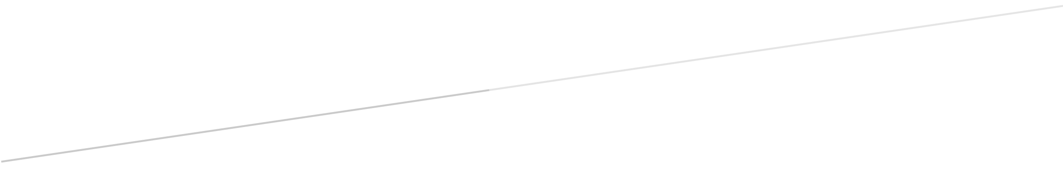

Table of Contents

Table of Contents 1

Introduction 3

Installation and Configuration 3

Basics 3

Authentication 4

Dashboard 5

Global Settings 6

Global Settings – Printers 7

Global Settings – File Systems 7

Users 8

Virtue Templates 9

Virtual Machine Templates 10

Applications 11

Virtue Instances 12

Virtual Machine Instances 13

User details – View mode 14

User details – Edit mode 15

User details – Create/Duplicate mode 16

Virtue details – View mode 17

Virtue details – Edit mode 18

Virtue details – Add Virtual Machine Templates 19

Virtue details – Virtue General Settings 20

Virtue details – Change Virtue Color 21

Virtue details – Add Clipboard Permissions 22

Virtue details – Virtue General Settings 2 23

Virtue details – Virtue Network Permissions 24

Virtue details – Manage Virtue Resources 25

Virtue details – Add File Systems 26

Virtue details – Add Printer 27

Virtue details – File System and Printer changes applied 28

Virtue details – Manage Virtue Sensors 29

Virtue details – Virtue Usage 30

Virtual Machine details – View Page 31

Virtual Machine details – Edit Page 32

Virtual Machine details – Add Applications 33

Virtual Machine details – Usage Page 34

# Introduction

The Administrator Workbench contains tools which allow an administrator to monitor and manage a Savior system’s users, virtues, virtual machines, and applications, as well as system resources, like shared file systems and printers.

# Installation and Configuration

The Administrator Workbench uses pm2 and http-server.

1. To set up the Workbench, first connect to the Debian- or Ubuntu-based Linux host, and navigate to the directory that contains workbench.tar. Run

mkdir ~/workbench

tar -xvf workbench.tar ~/workbench

1. Tell the Workbench where the virtue-server backend is, by editing

~/workbench/assets/json/baseUrl.json

and updating the ‘virtue-server’ address to match your virtue-admin server address.

1. Install npm, pm2, and http-server:

curl -sL <https://deb.nodesource.com/setup_11.x> | sudo -E bash -

sudo apt-get install nodejs

sudo npm -g install pm2 && sudo npm -g install http-server

1. To start the server, run:

cd ~/workbench; sudo pm2 start `which http-server` -- -p 80 -d false

1. To restart the server, run:

sudo pm2 restart {ID of server, probably 0}

The site should now be running, and can be accessed by navigating to

http://{workbench’s_IP_address}/#/login

Note that the address on which the workbench gets deployed will need to be marked as safe in the cors settings of the backend.

# Basics

Navigation:

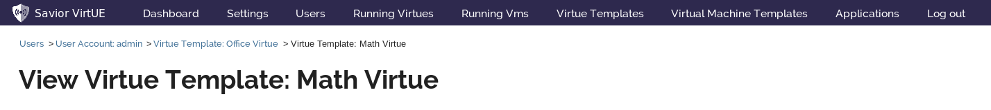

Figure 1 - Navigation

The workbench can be easily navigated by using the main menu at the top of the application, as well as through Breadcrumbs. The breadcrumbs allow the user to see their history and backtrack up until their last main page. Loops are removed, to minimize the length of the list.

Some pages have a ‘Return’ button, which will take the user back to whatever page they were last on, before the current page.

## Authentication

The workbench uses the same Active Directory instance as the Virtue-server, and all workbench activity must take place in an authenticated session. On any authentication failure, the workbench will request a logout and return to the login page.

This webapp was written in Angular, and so has substantial built-in protection against XSS attacks. CSRF protection will be added in the future.

Note on a bug: if authentication fails, the page will stick in the ‘Waiting for Data’ state with no clear indication of that authentication failure, and the user must manually click Log Out or navigate to http://{workbench’s_IP_address}/#/login.

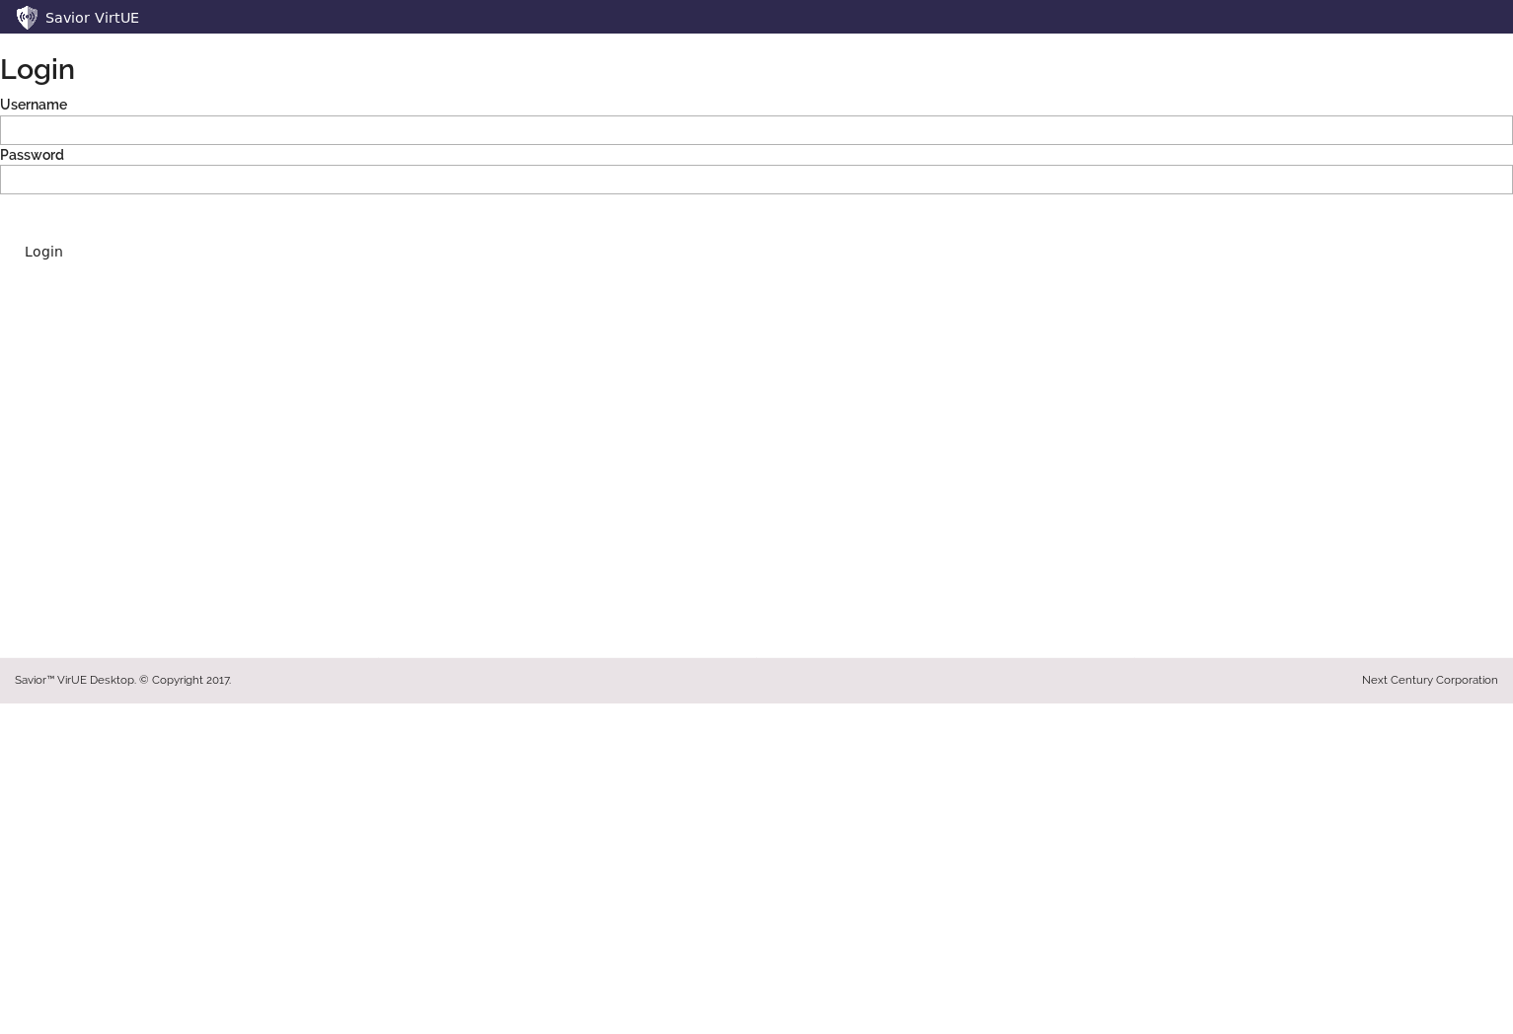

Figure 2 - Login Page

# Dashboard

The dashboard will allow the administrator to monitor and respond to important events in the system.

Currently, the dashboard shows a list of the most recent sensor events. In a future phase, once functionality is implemented to detect potential threats through the sensors, those notifications will be listed here, each with some actions the administrator may wish to take in response.

A future version will also enable the administrator to sort, filter, search, and download the logs.

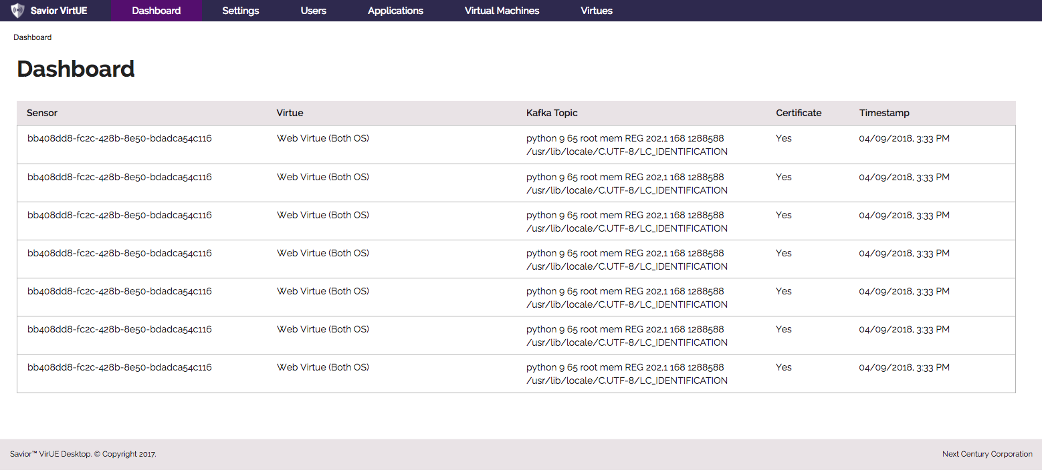

Figure 3 - Example of Dashboard Screen

# Global Settings

The Settings views will allow the administrator to configure the Active Directory settings for the the system, permissions for Resources (file systems and printers), and settings for globally-applicable Sensors. Global sensor settings cannot be configured from this version of the workbench; they, along with a history of previous global settings configurations, will be added in a future version.

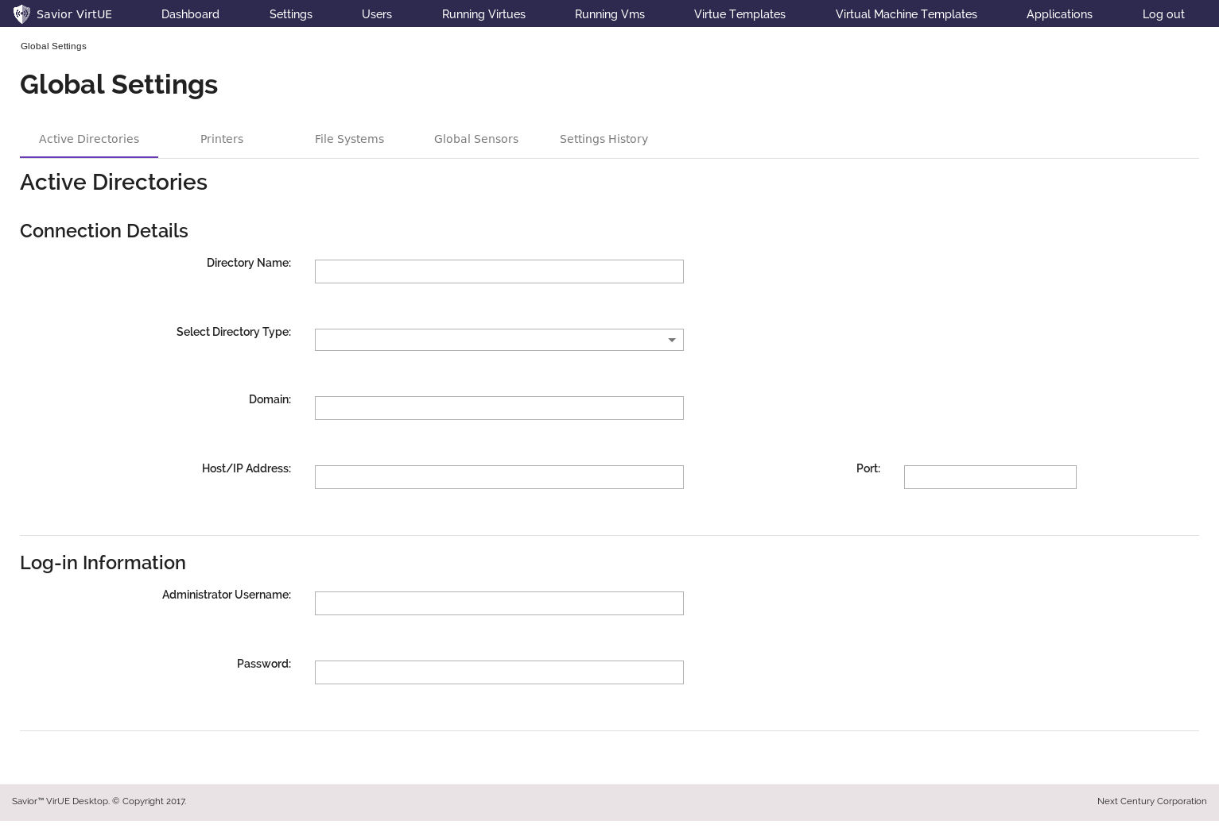

Figure 4 - Active Directories Screen

# Global Settings – Printers

From the Printers page, the administrator will be able to make new printers available to the system, manage their settings, and monitor their status. This page is not yet functional, and will be made so in a future version.

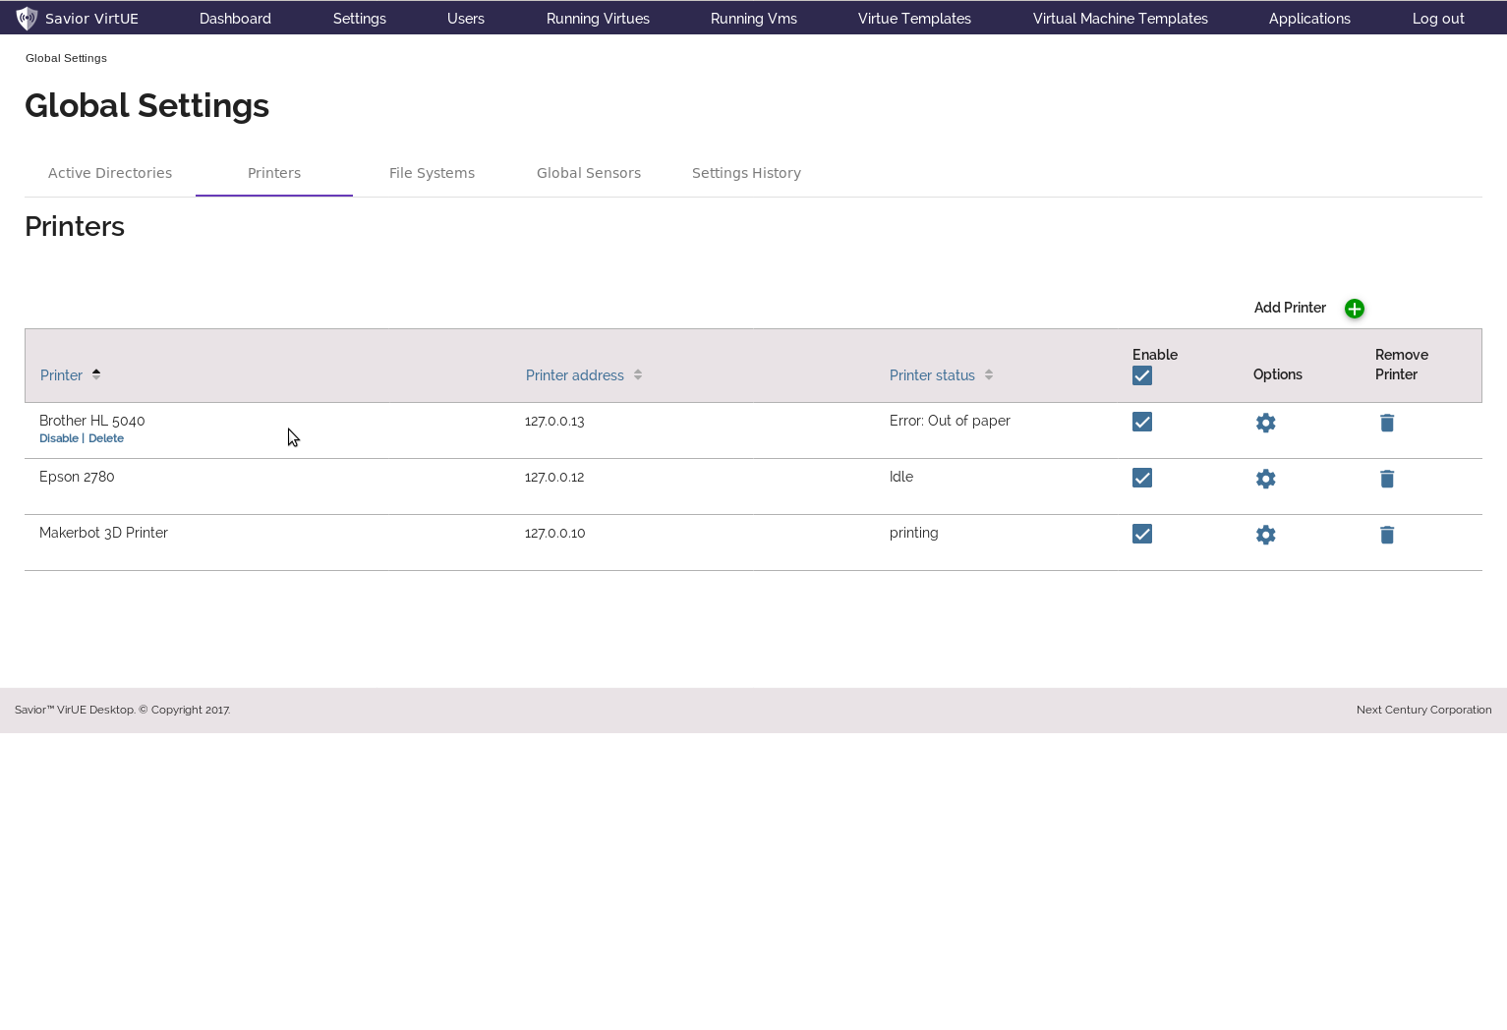

Figure 5 - Printer Settings

# Global Settings – File Systems

From the File Systems page, the administrator can make new file system endpoints available to the system, disconnect existing file systems, and set their maximum permissions.

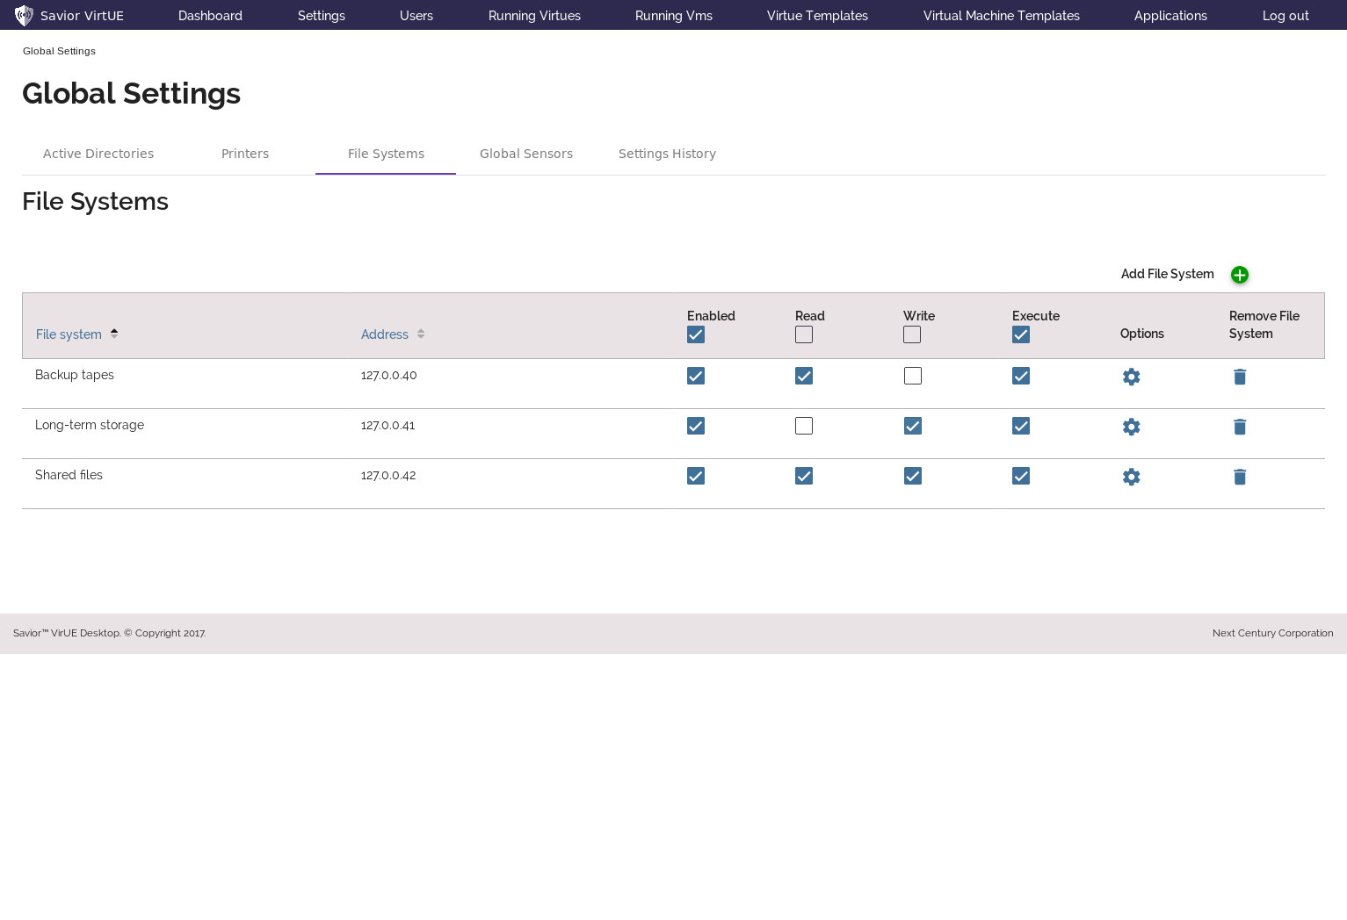

Figure 6 - File System Default Permissions

# Users

The Users view provides a list of all the users that have been created, along with their roles, permissions, and status.

The administrator can add new users using the ‘Add User’ button at the top of the screen, as well as disable, edit, duplicate, or delete existing ones using the sub-menu that appears on each row in the table.

Disabled user accounts are grayed-out, and filters are provided above the table for filtering in or out all enabled or disabled users. Furthermore, the table can be sorted by clicking the blue header on any sort-able column.

Click on any link in the table to navigate to a page for that particular user or template.

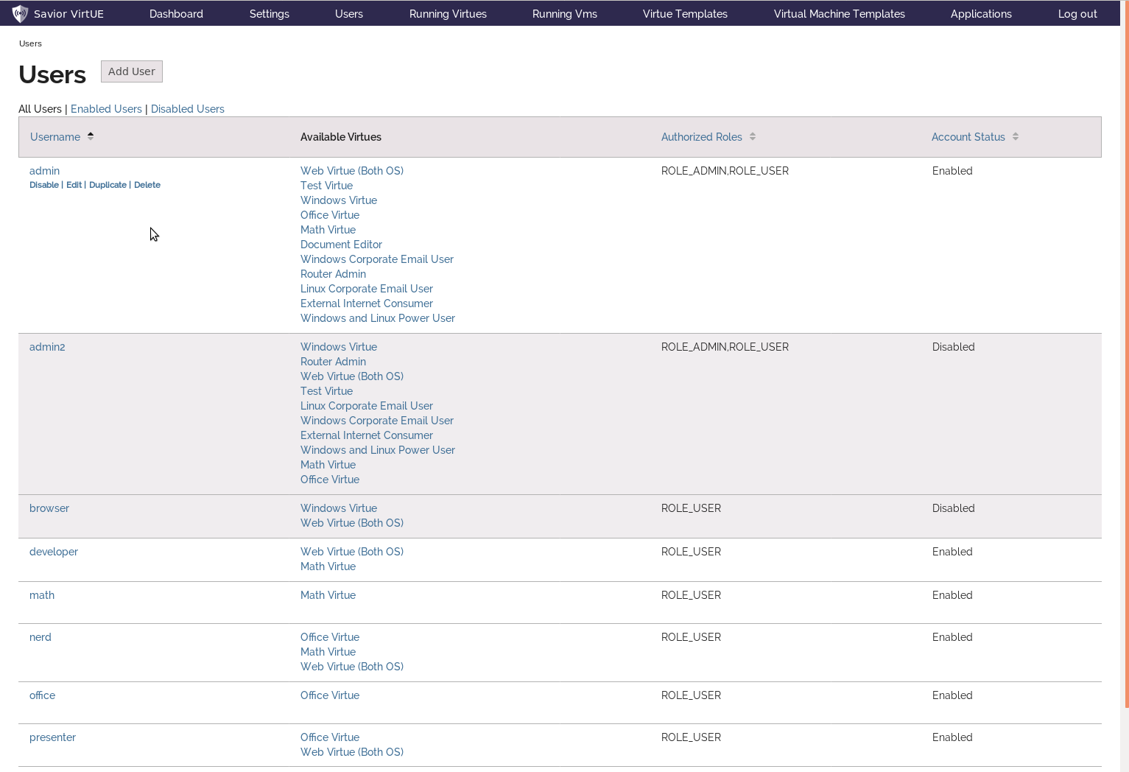

Figure 7 - Users and Roles Management

# Virtue Templates

The Virtue Templates view provides a list of all the virtue templates that have been created, along with some of their details.

The administrator can add new virtue templates using the ‘Add Virtue Template’ button at the top of the screen, as well as disable, edit, duplicate, or delete existing ones using the sub-menu that appears on each row in the table.

Disabled virtues are grayed-out, and filters are provided above the table for filtering in or out all enabled or disabled virtues. Furthermore, the table can be sorted by clicking the blue header on any sort-able column.

Click on any link in the table to navigate to a page for that particular virtue template or virtual machine template.

Virtues are labeled with their administrator-defined color, as an organizational aid.

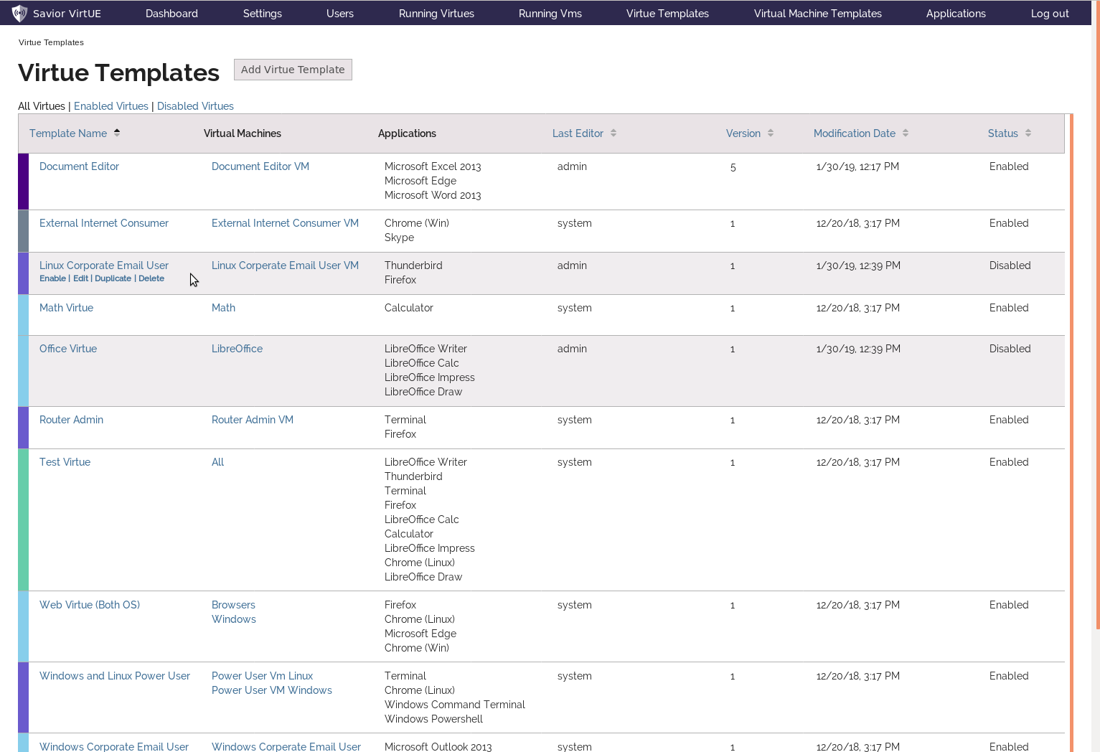

Figure 8- Virtue Template Management

# Virtual Machine Templates

The Virtual Machine Templates view provides a list of all the virtual machine (VM) templates that have been created, along with some of their details.

The administrator can add new VM Templates using the ‘Add VM Template’ button at the top of the screen, as well as disable, edit, duplicate, or delete existing ones using the sub-menu that appears on each row.

Disabled VM templates are grayed-out, and filters are provided above the table for filtering in or out all enabled or disabled VM templates. The table can be sorted by clicking the blue header on any sort-able column.

Click on any link in the table to navigate to a page for that particular VM template.

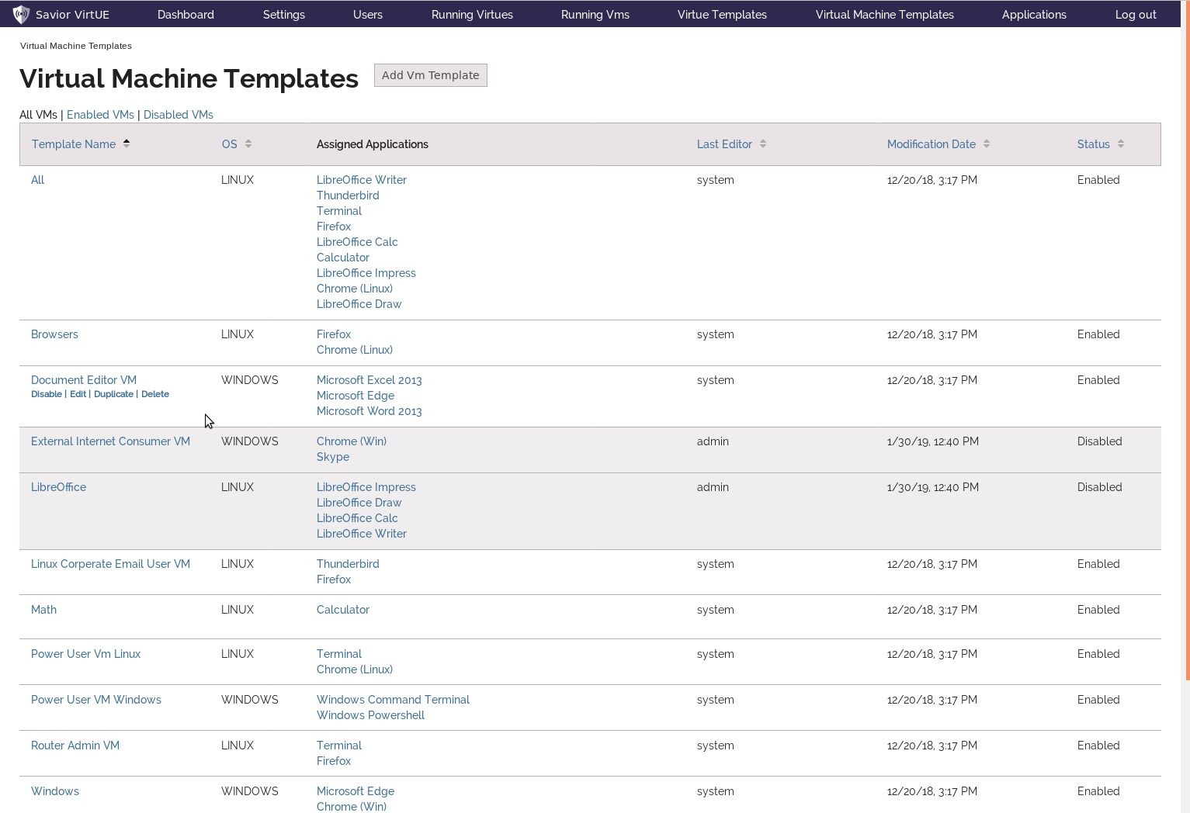

Figure 9 - Virtual Machine Template Management

# Applications

The Applications view provides a list of all the applications that have been installed and added to virtual machines. In future versions, administrators will be able to install and manage applications through the user interface.

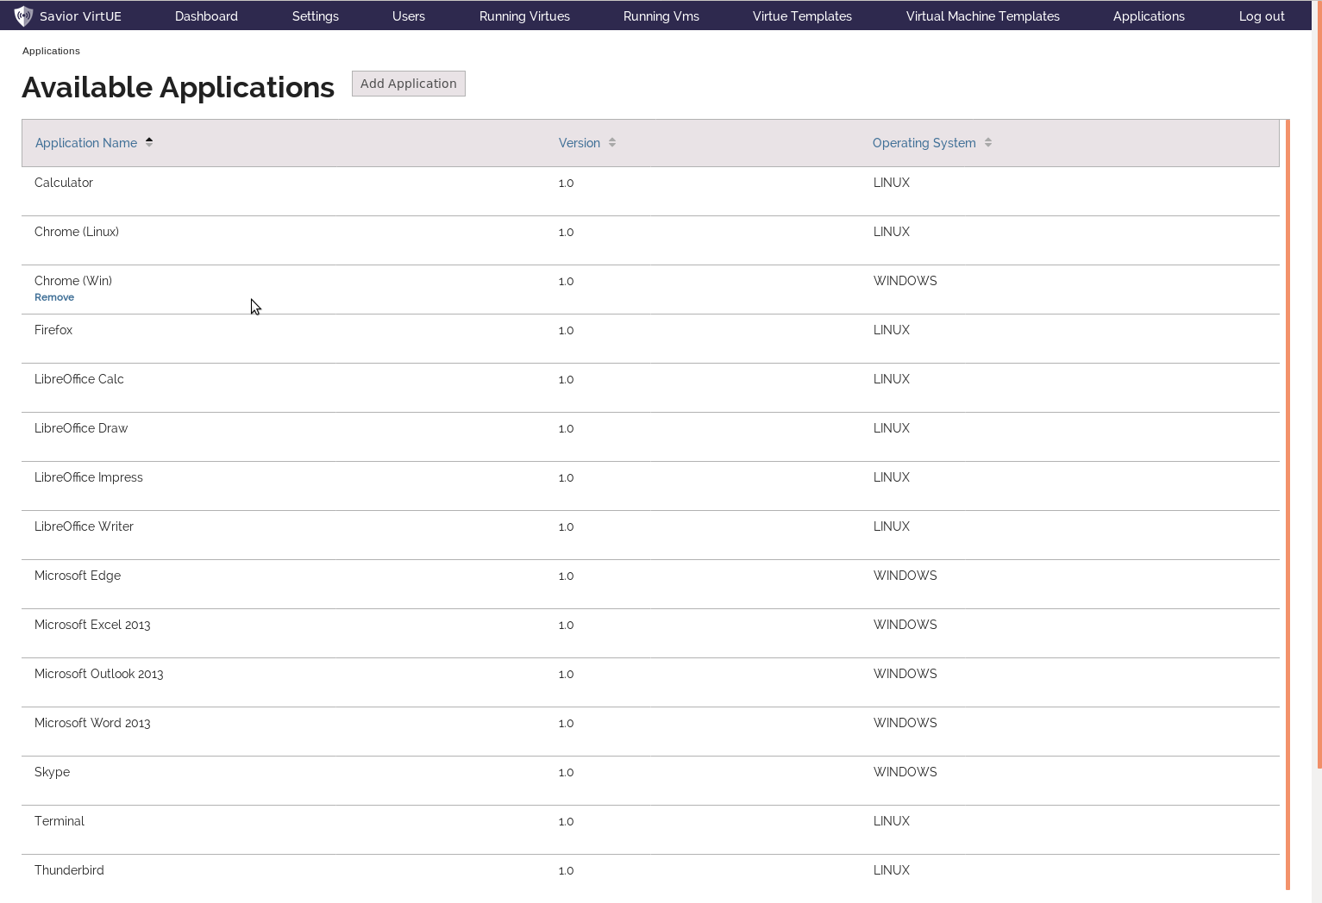

Figure 10 - Applications Management

# Virtue Instances

The Virtue Instances view provides a list of all the actual Virtue instances in the system, along with their status and the names of their virtual machine instances.

Each Virtue instance is labeled with the same administrator-defined color as the template they were created from, and also comes with a link to the details page for that template.

Like the other tables, this one can also be sorted on any column with a blue header.

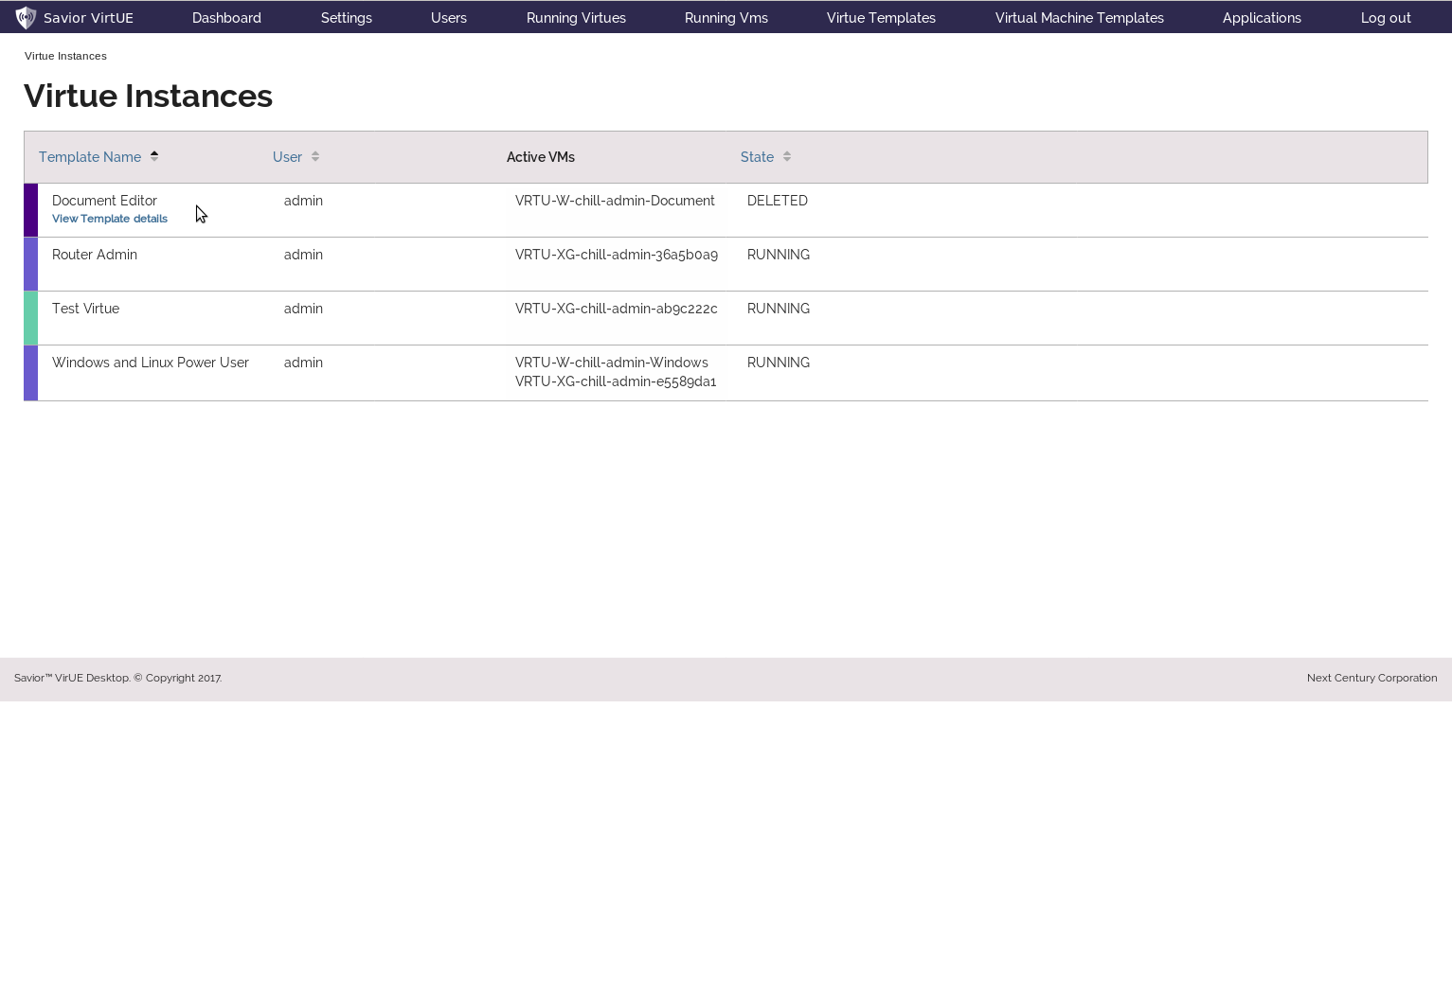

Figure 11 - Virtue Instance Monitoring

# Virtual Machine Instances

The Virtual Machine Instances view provides a list of all the Virtual Machine instances in the system, along with their status, operating system type, and hostname.

Like the other tables, this one can also be sorted on any column with a blue header.

A link to the details page for the template corresponding to each VM instance will be added in the future.

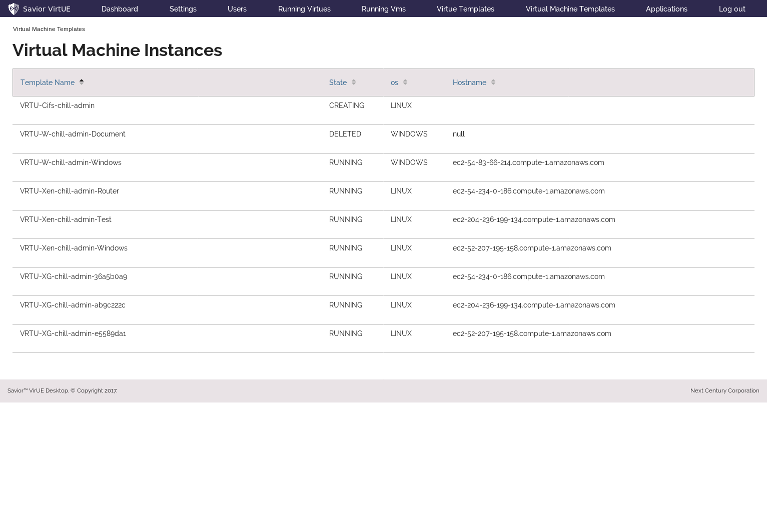

Figure 12 - Virtual Machine Instance Monitoring

# User details – View mode

The View User page allows the administrator to view a user’s roles and assigned templates, as well as enable or disable their account. For convenience, those assigned templates are linked, so the administrator can navigate there directly, if they wish to change something about a user’s virtue.

At the bottom are two buttons:

* ‘Return’ will take you to whichever page you were last on before you came to this one
* ‘Edit’ will enable editing on this user page.

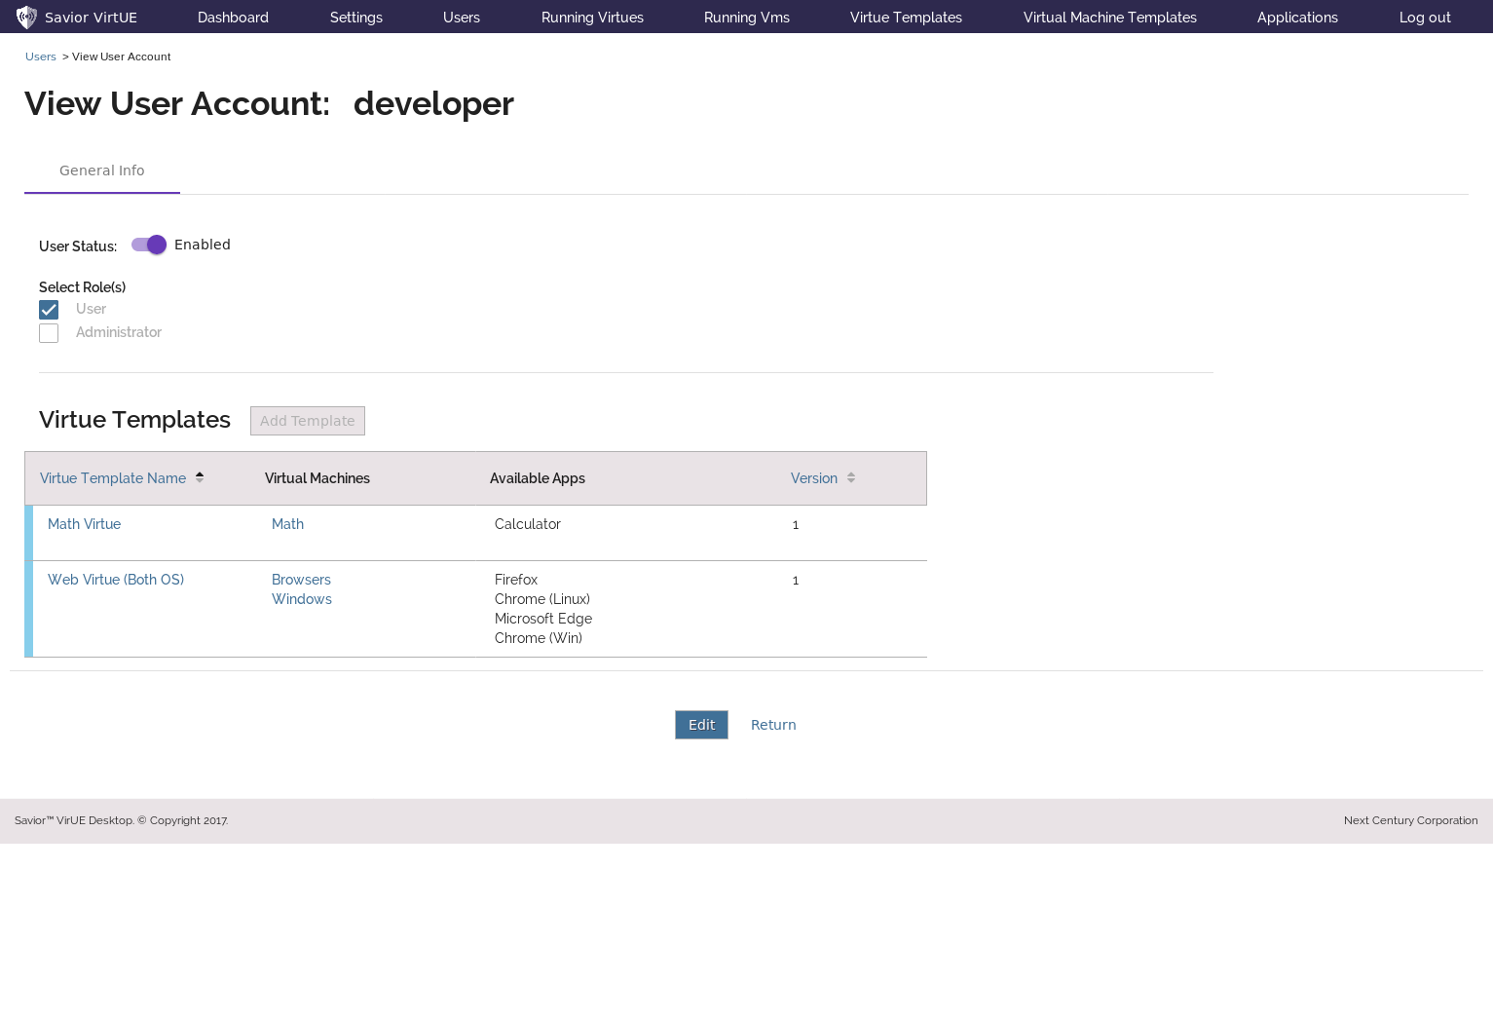

Figure 13 - View User Details

# User details – Edit mode

The Edit User page allows the administrator to edit a user’s roles and assigned templates. Changes here are **not** made permanent until either the ‘Save’ or ‘Save and Return’ buttons are pressed.

Roles: Users may have either or both roles.

Templates: Add templates to give the user access to those types of Virtue.

Navigation to the user’s assigned templates is turned off in this mode, to lessen the likelihood of the user leaving the page without realizing their changes haven’t been saved. Toggling the user’s status is also disabled.

At the bottom are three buttons:

* ‘Cancel’ will discard any changes and return the user to the view page
* ‘Save’ will save any changes and return the user to the view page
* ‘Save and return’ will save your changes and take you back to whichever page you were last on before you came to this one.

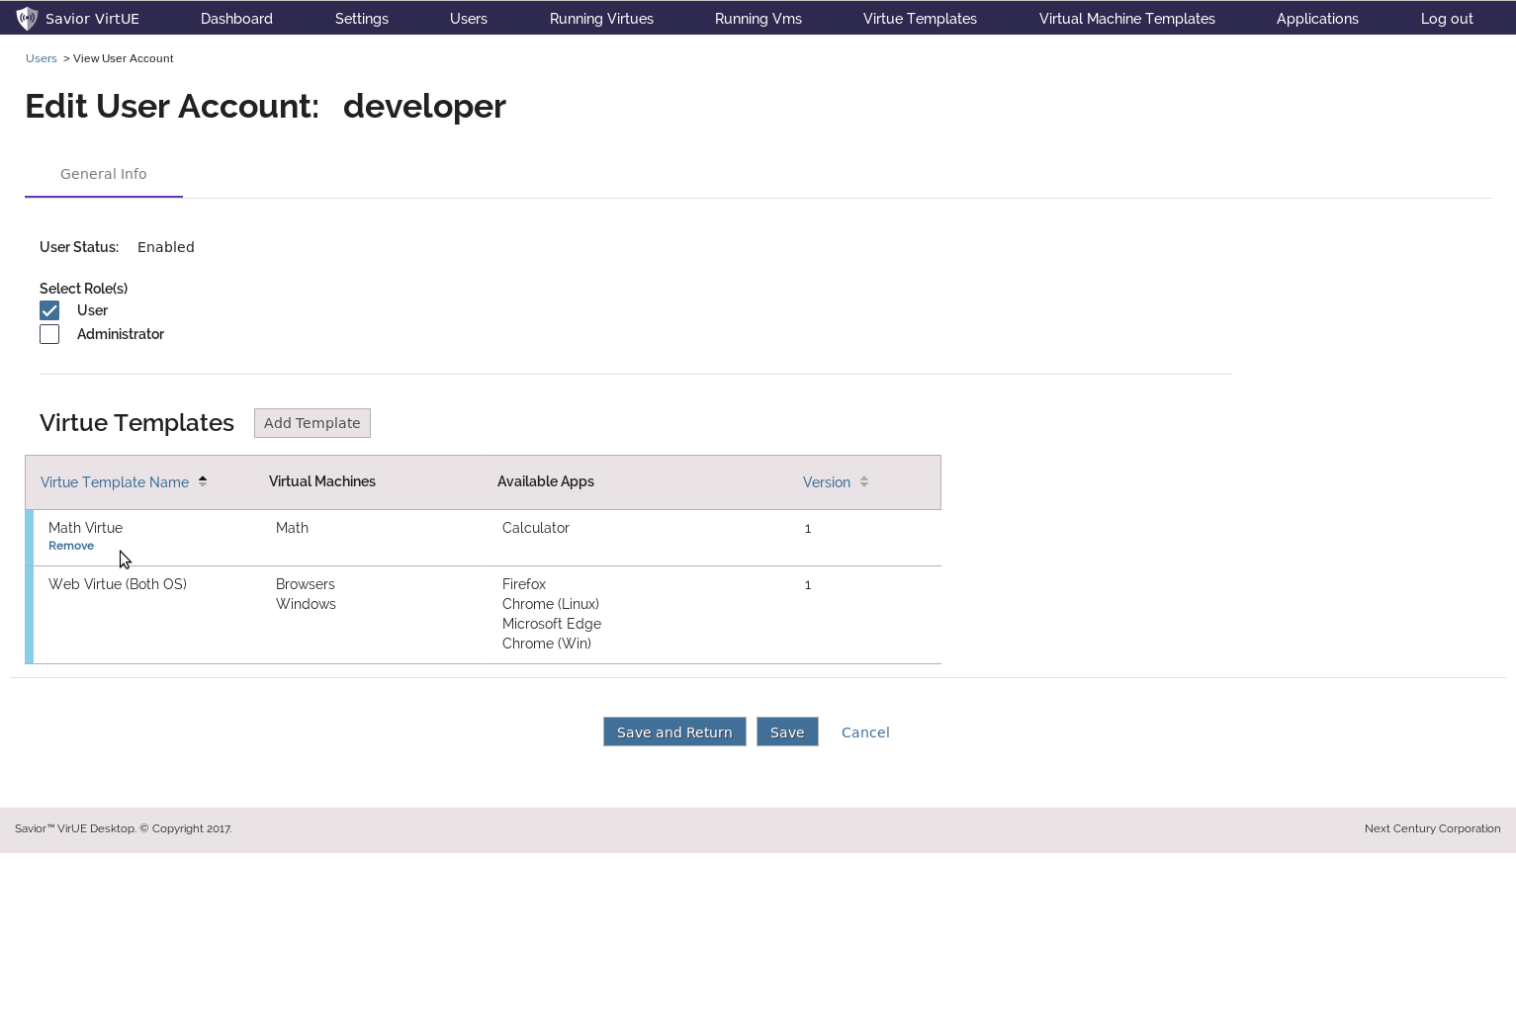

Figure 14 - Edit User Details

# User details – Create/Duplicate mode

The Create and Duplicate User pages allow the administrator to create a new User. Duplicate mode is Create mode with all fields pre-filled with an existing user’s information.

The page is otherwise the same as the User Edit page.

Note that a user’s name can’t be changed after creation.

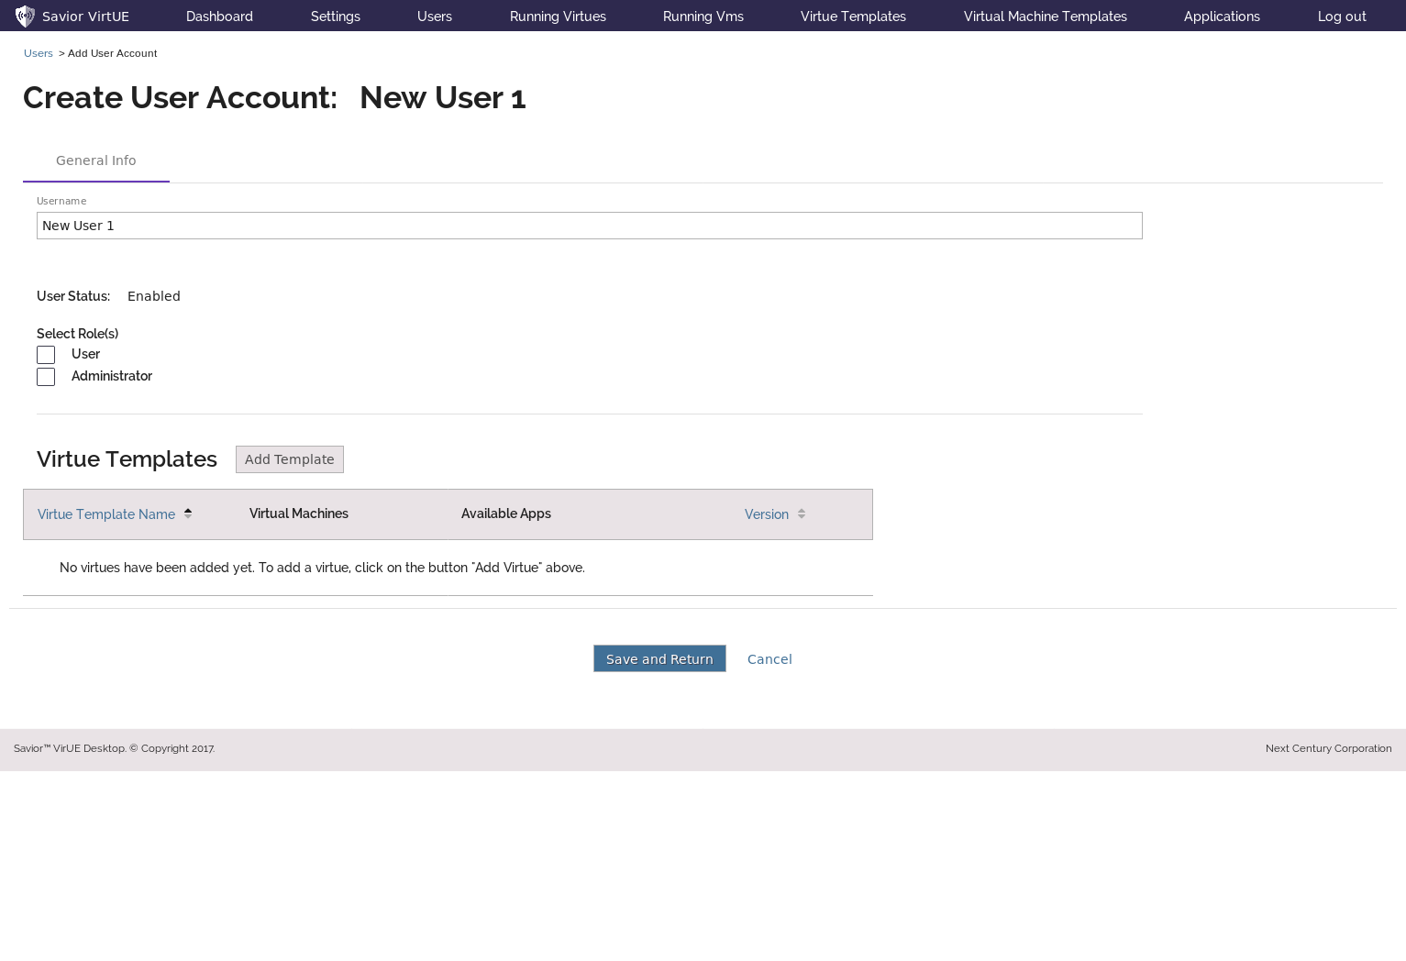

Figure 15 - Create New User

# Virtue details – View mode

The View Virtue page allows the administrator to view a virtue template’s settings, assigned VM templates, the users who have been granted use of the template, as well as the Virtue Instances which have been created from the template. For convenience, those assigned VM templates are linked, so the user can navigate there directly.

Each virtue has a version number, which simply counts how many times this virtue has been edited - This allows an administrator to discern between a running Virtue created from a particular template, and a different running Virtue created from an earlier (perhaps flawed) version of the same template. In the future, a new tab will be added to track the history of changes made to the virtue, so previous versions can be compared, and possibly restored.

At the bottom are two buttons:

* ‘Return’ will take you to whichever page you were last on before you came to this one
* ‘Edit’ will enable editing on this virtue.

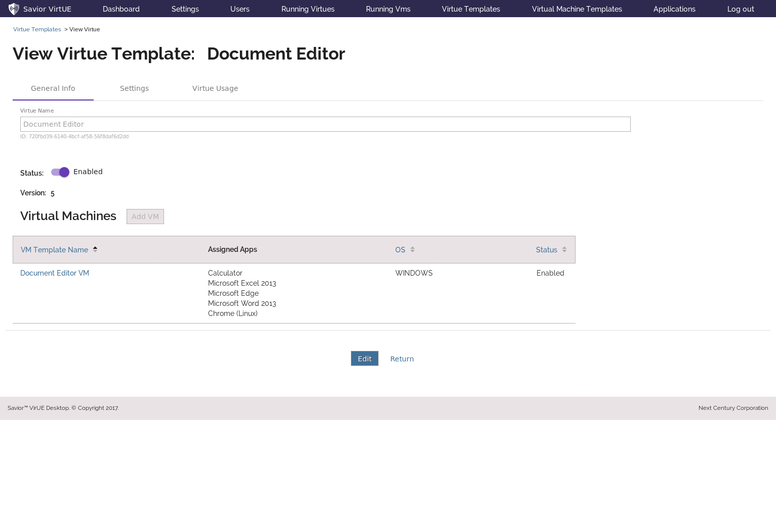

Figure 16 - View Virtue Details

# Virtue details – Edit mode

Edit mode shows all the same information as View mode (above), but is read-only. The remaining sections of the Virtue Details View will be shown in Edit mode.

The Edit Virtue page allows the administrator to edit a virtue template’s settings and assigned virtual machine templates. Changes here are **not** made permanent until either the ‘Save’ or ‘Save and Return’ buttons are pressed.

Under the Virtue’s name are three tabs, which will be described in the next few pages.

Navigation to the virtue’s assigned templates is turned off in this mode, to lessen the likelihood of the user leaving the page without realizing their changes haven’t been saved. Toggling the virtue’s status is also disabled.

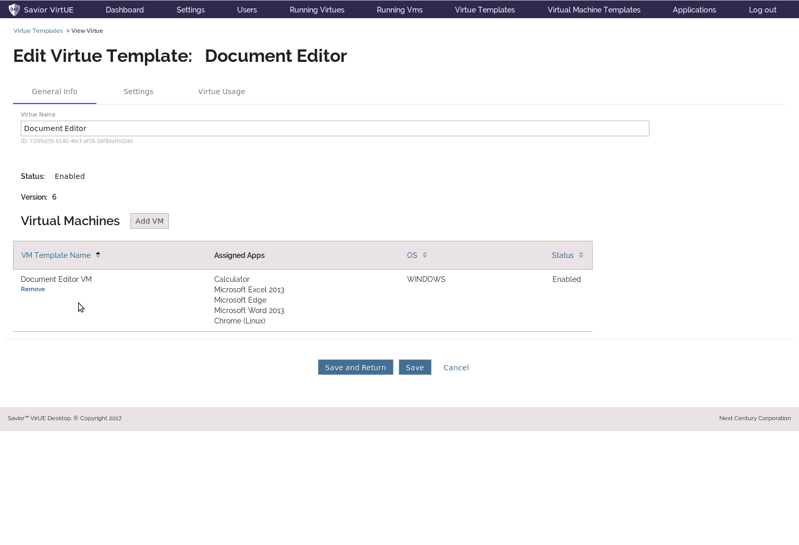

Figure 17 - Edit Virtue Template

# Virtue details – Add Virtual Machine Templates

From this pop-up, the administrator can add and remove VM templates to/from the Virtue.

Select VM Templates to add using the check boxes on the left hand-side of the table, or select/deselect all templates using the checkbox on the left side of the header.

Select ‘Submit’ to set the selected templates on this virtue, or ‘Cancel’ to discard your changes.

Like the other tables in this system, this table can be sorted on any column with a blue header, by clicking on that header.

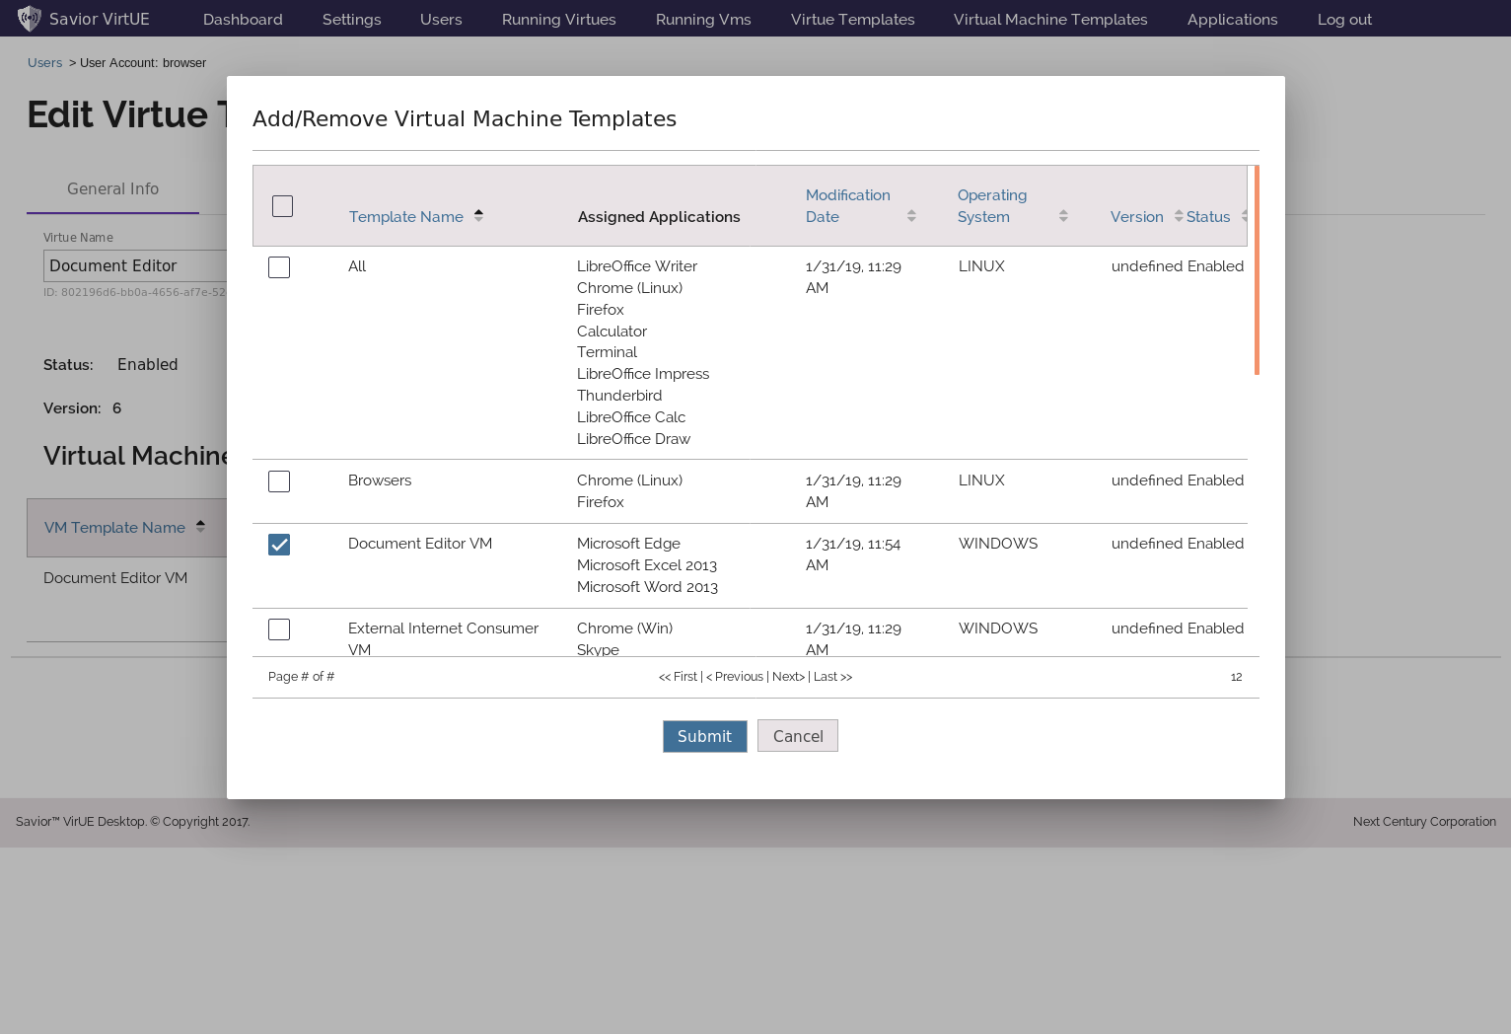

Figure 18 - Edit Virtue Template – Add VM Templates

# Virtue details – Virtue General Settings

From the Virtue Settings tab, the administrator can manage many aspects of the Virtue Template. These settings are broken up into four sub-tabs: General, Network, Resources, and Sensors.

All of these tabs are on the same ‘page’, and so there is no need to save between tab changes.

Virtues can be given a color as an organizational aid. This color will show up wherever that Virtue shows up in the workbench, as well as in the Desktop App. Administrators can click on the colored square to bring up a selection of colors options.

Virtues can also be granted clipboard permissions, to allow that virtue to copy and paste data to/from a separate virtue. Add a new permission by clicking on the  labeled ‘Add virtue’.

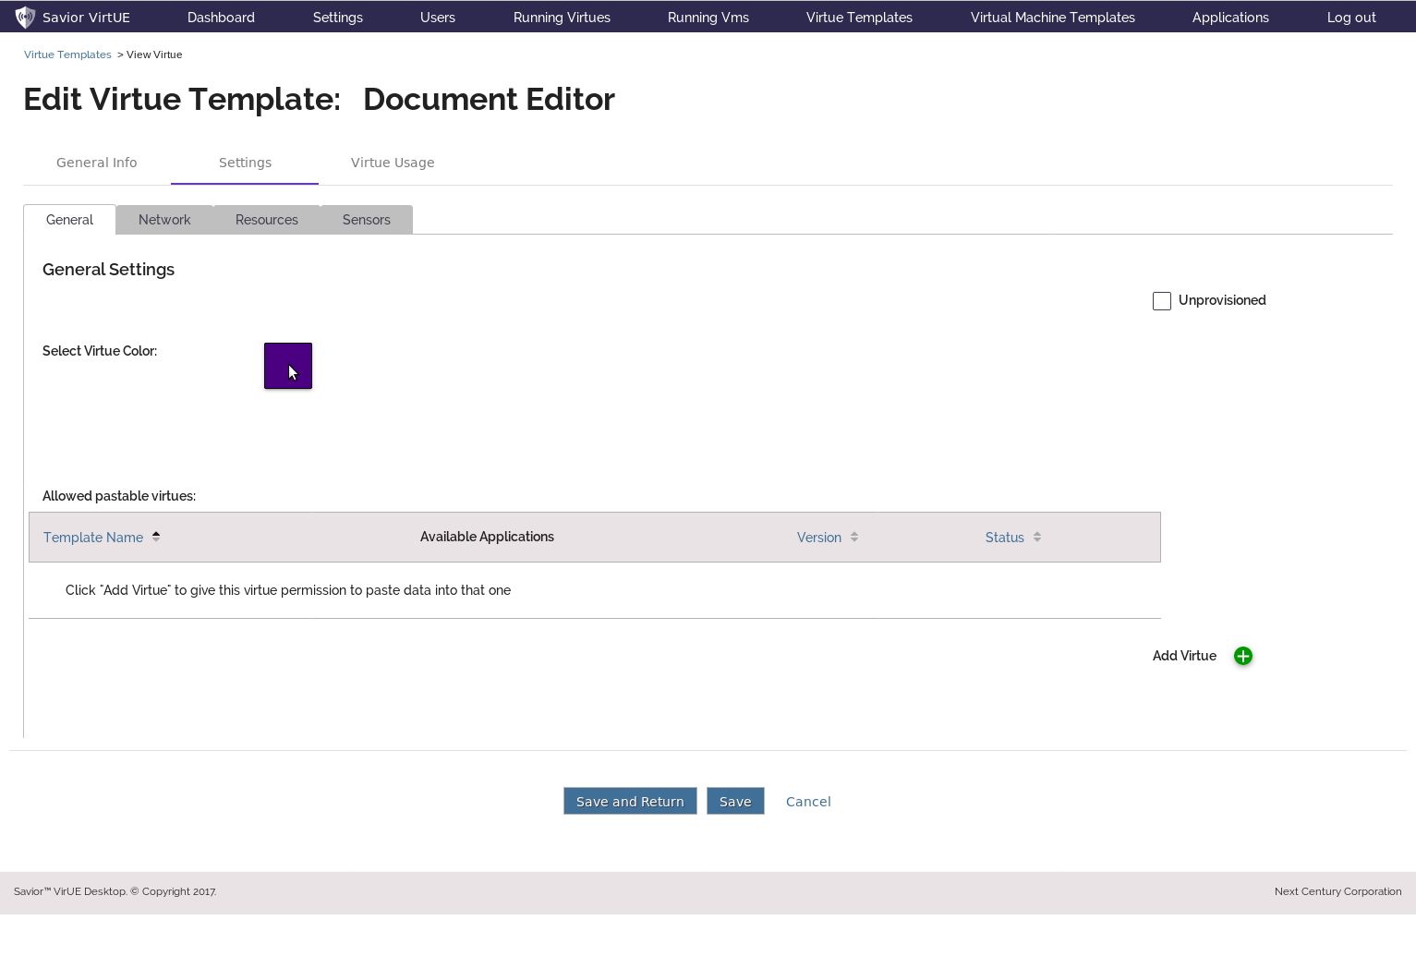Figure 19 - Edit Virtue Template - Change Color

# Virtue details – Change Virtue Color

From this pop-up, the administrator can select a color to label the virtue with. The default color options are standard, high-contrast, html colors, but in the future an option to define custom colors will be added.

Select ‘Submit’ to add the selected templates to this virtue, or ‘Cancel’ to discard your changes.

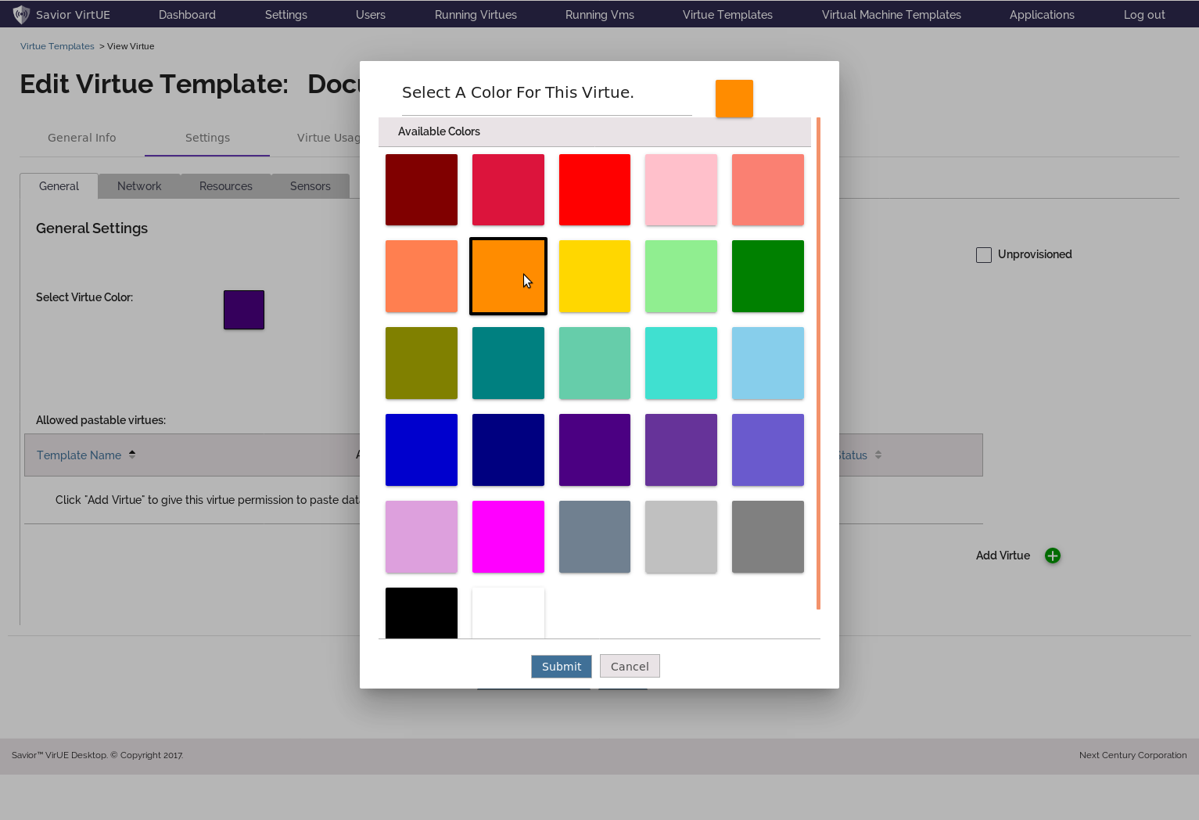Figure 20 - Edit Virtue Template - Select Color

# Virtue details – Add Clipboard Permissions

From this pop-up the administrator can select virtues to grant permission to copy/paste to/from this virtue.

Select ‘Submit’ to add the selected templates to this virtue, or ‘Cancel’ to discard your changes.

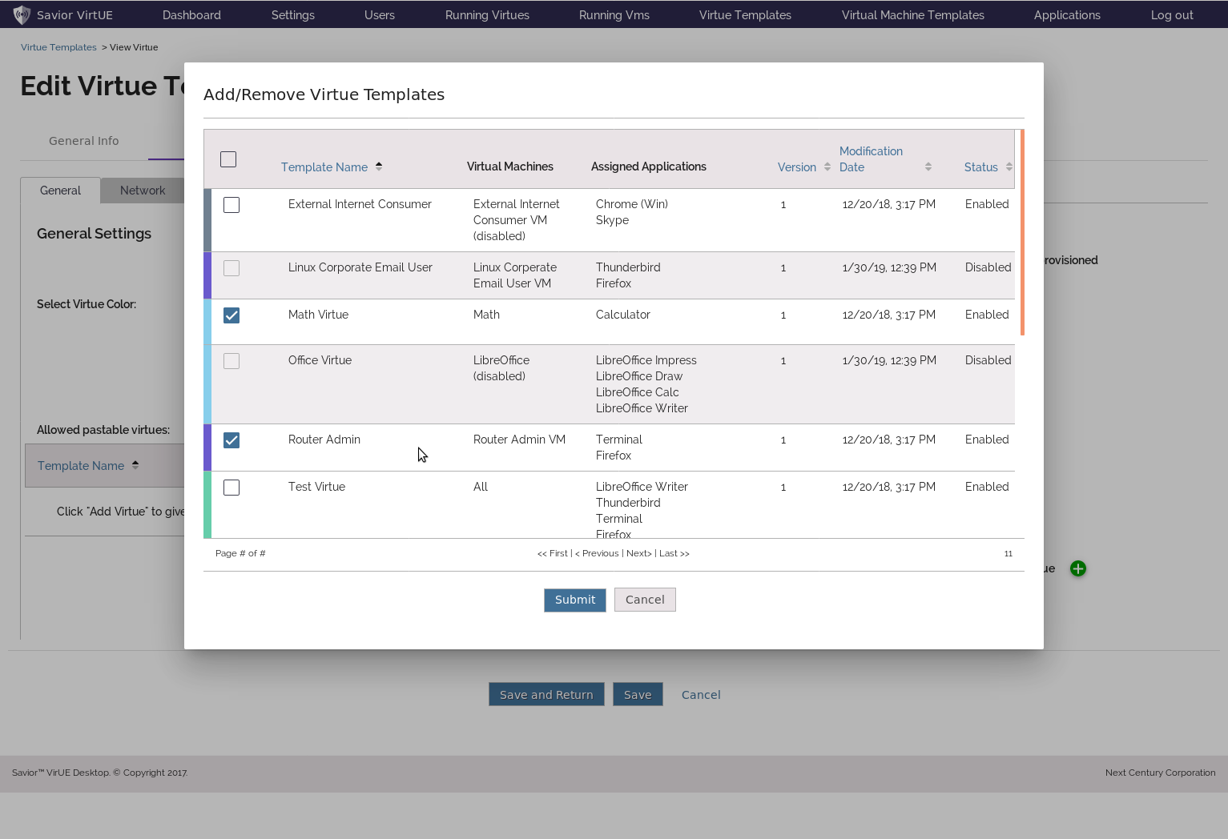

Figure 21 - Edit Virtue Template – Grant Clipboard Permissions

# Virtue details – Virtue General Settings 2

This page shows the result of the previous two pages’ changes to the Color and Clipboard Permissions settings.

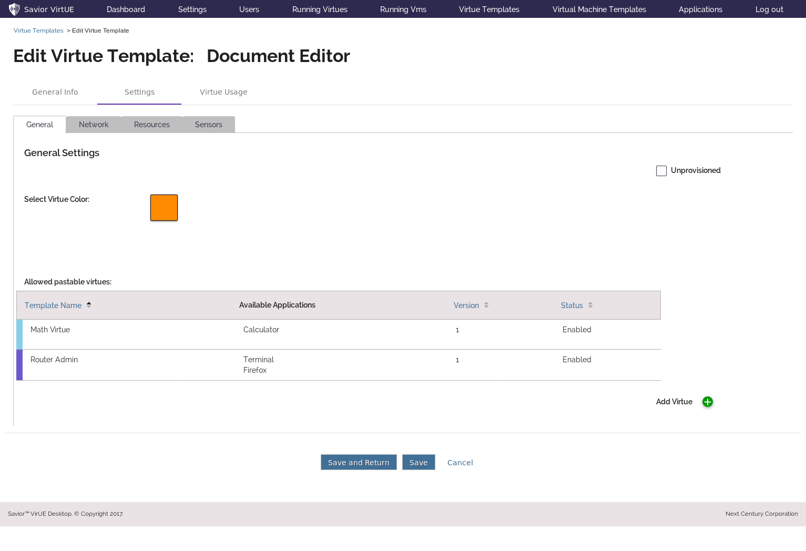

Figure 22 - Edit Virtue Template - New Color and Paste Permissions Applied

# Virtue details – Virtue Network Permissions

The Network tab allows the Administrator to manage any number of network permissions for this virtue.

Network connections can be TCP/IP, ICMP, or UDP/IP.

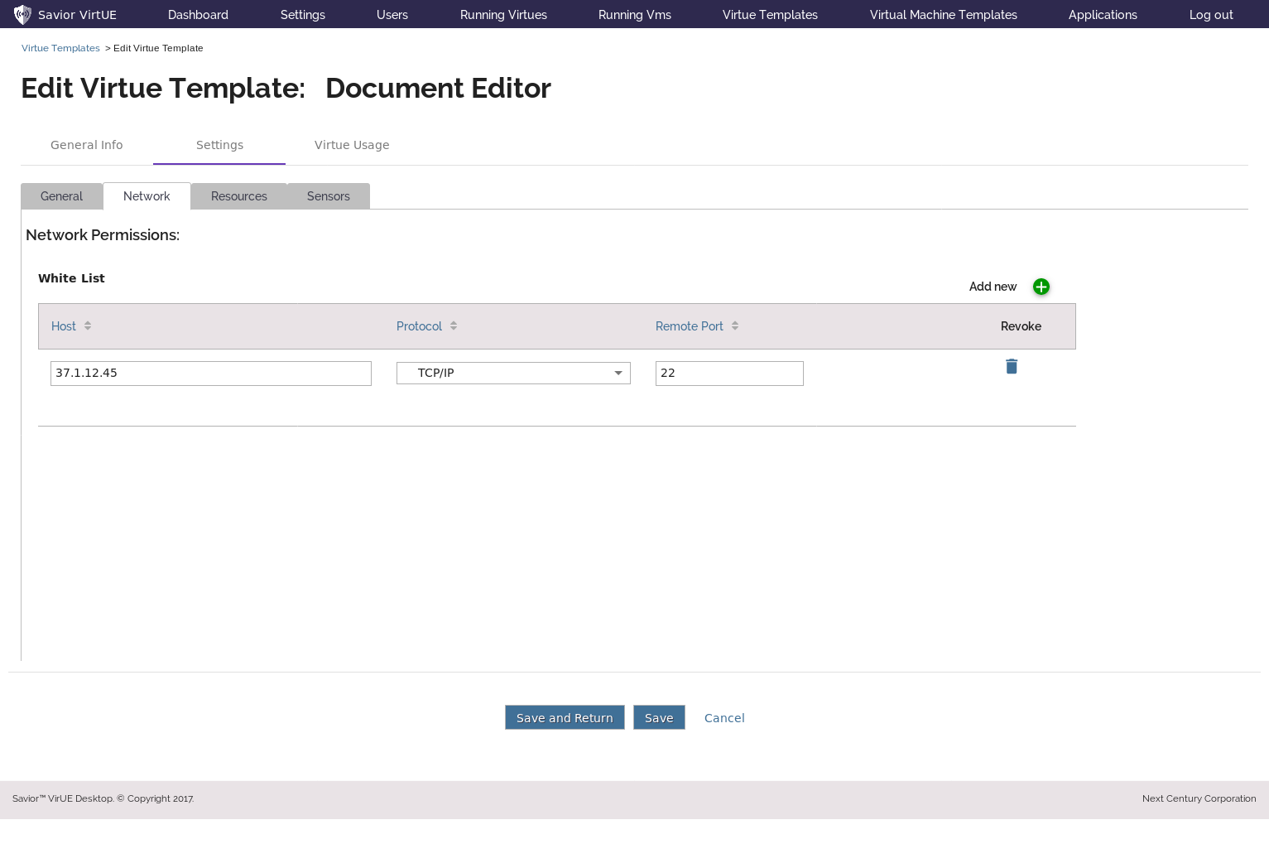

Figure 23 - Edit Virtue Template – Network Permissions

# Virtue details – Manage Virtue Resources

From the Resources tab, the administrator can manage this virtue’s access to the system’s known File Systems and Printers (see Global Settings Pages).

File Systems come in with their default global permissions, but can be customized for each virtue.

New File Systems or Printers can be attached by clicking the  next to the respective table.

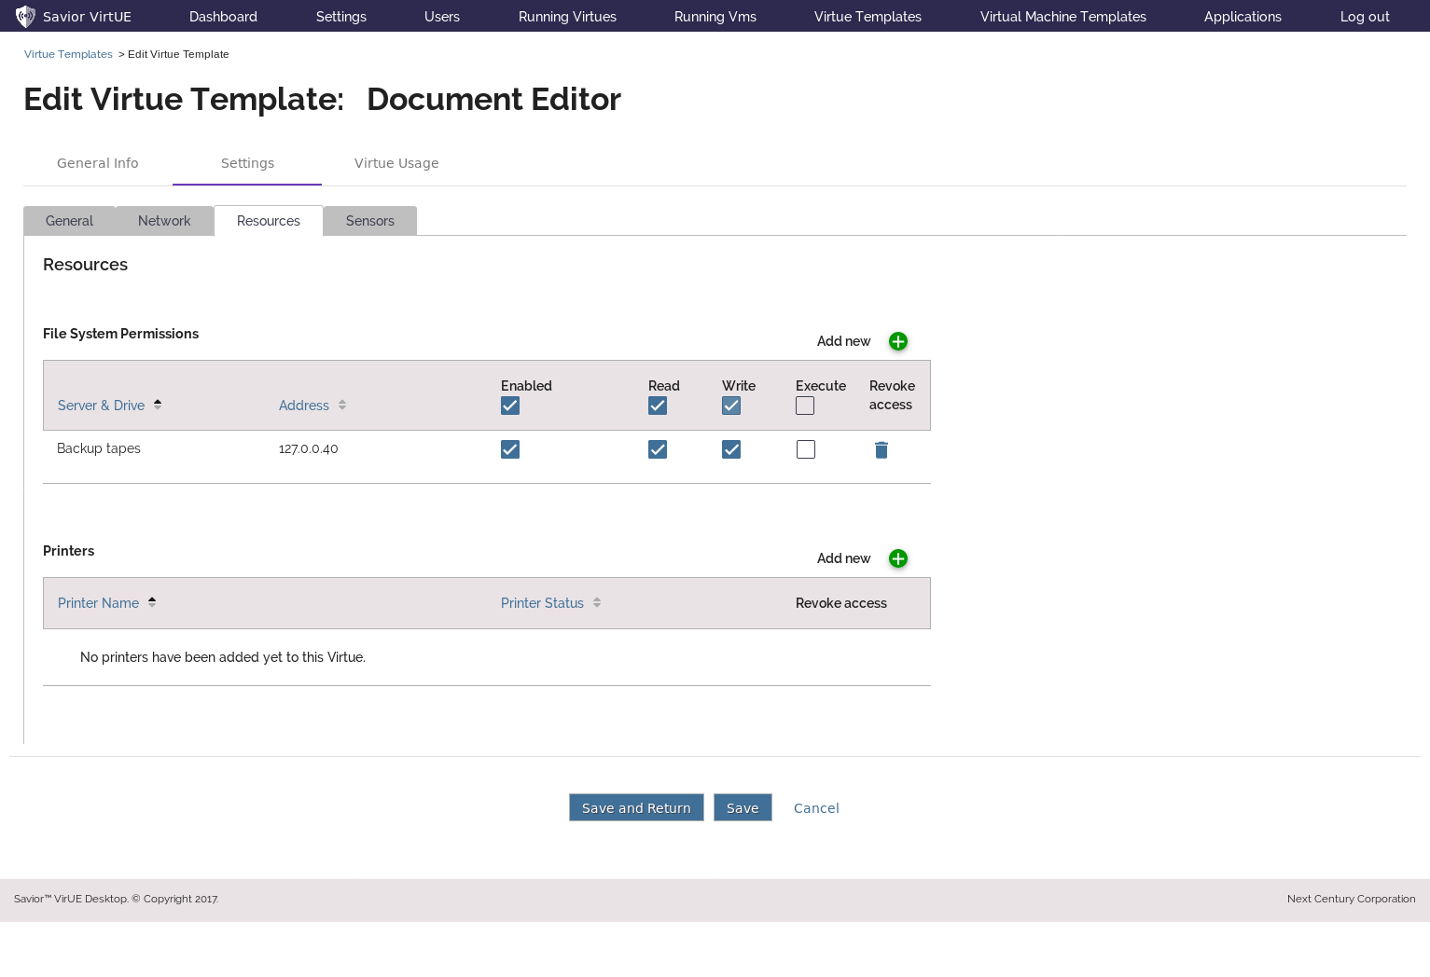

Figure 24 - Edit Virtue Template – Resource Permissions

# Virtue details – Add File Systems

From this pop-up the administrator can view the properties of available file systems, and select which one(s) to grant the virtue access to.

Select ‘Submit’ to add the selected file systems to this virtue, or ‘Cancel’ to discard your changes.

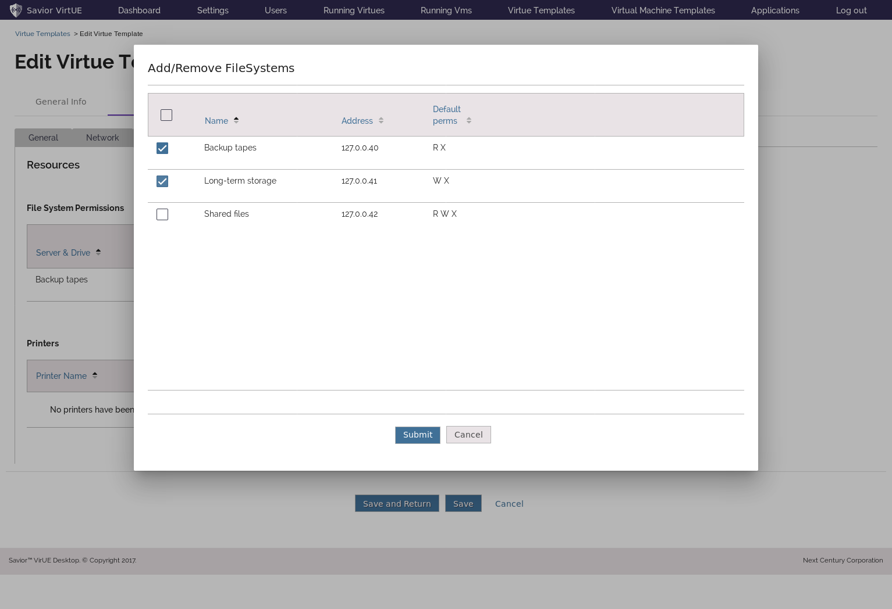

Figure 25 - Edit Virtue Template – Add File Systems

# Virtue details – Add Printer

From this pop-up the administrator can view the properties of available printers, and select which one(s) to grant the virtue access to.

Select ‘Submit’ to add the selected printers to this virtue, or ‘Cancel’ to discard your changes.

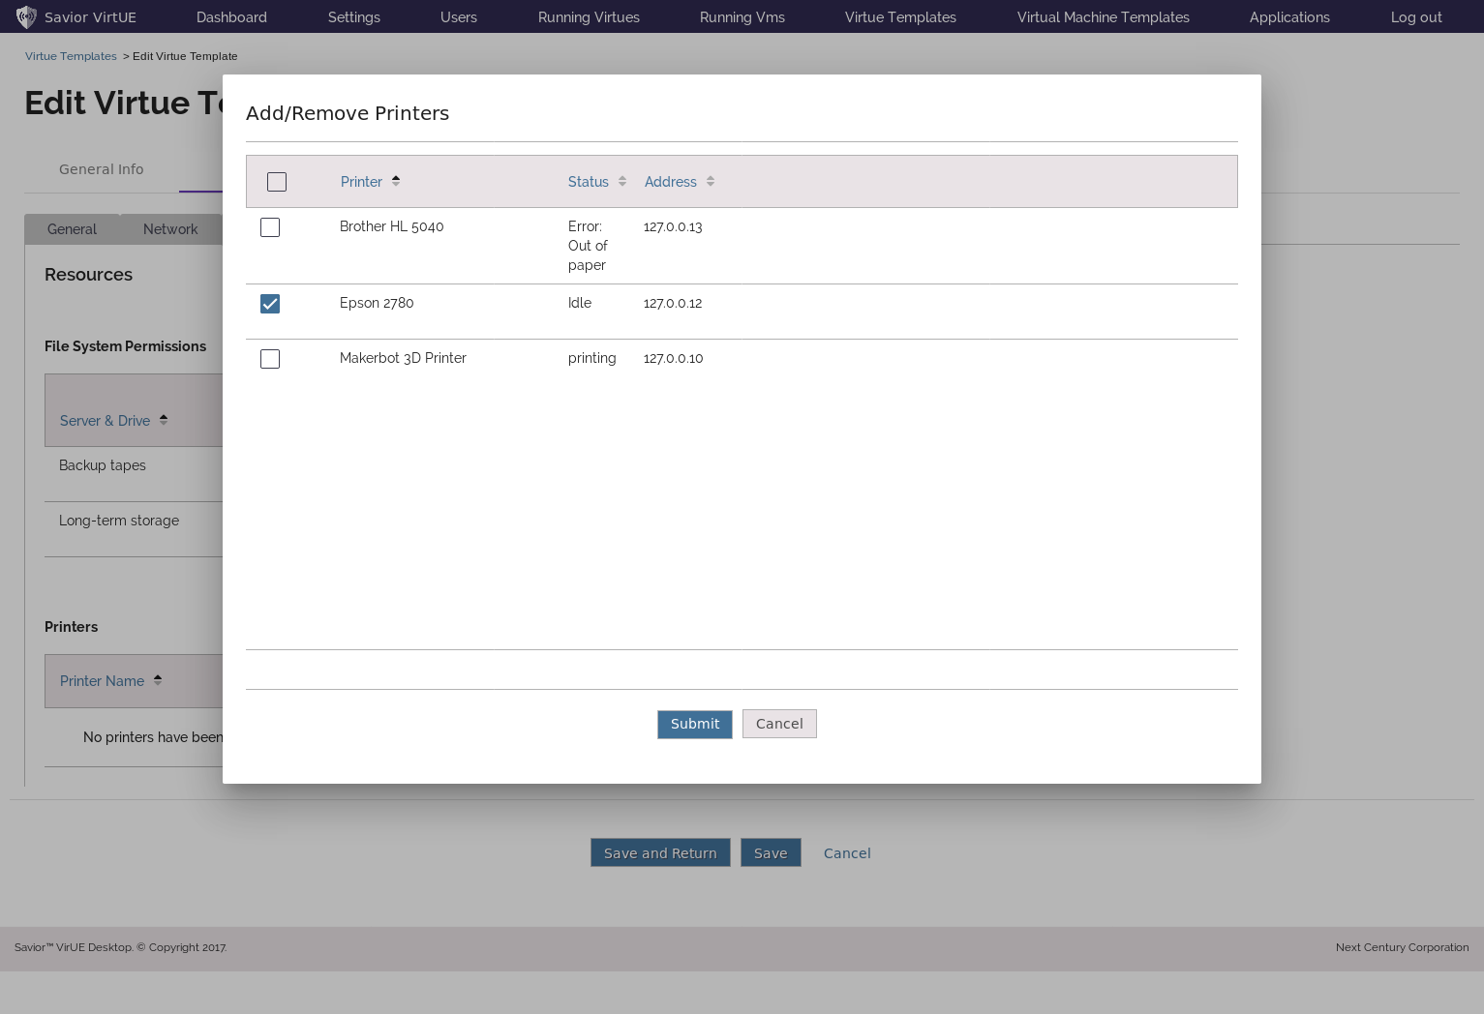

Figure 26 - Edit Virtue Template – Add Printers

# Virtue details – File System and Printer changes applied

This page shows the results of adding a file system, changing both file systems’ permissions, and attaching a new printer.

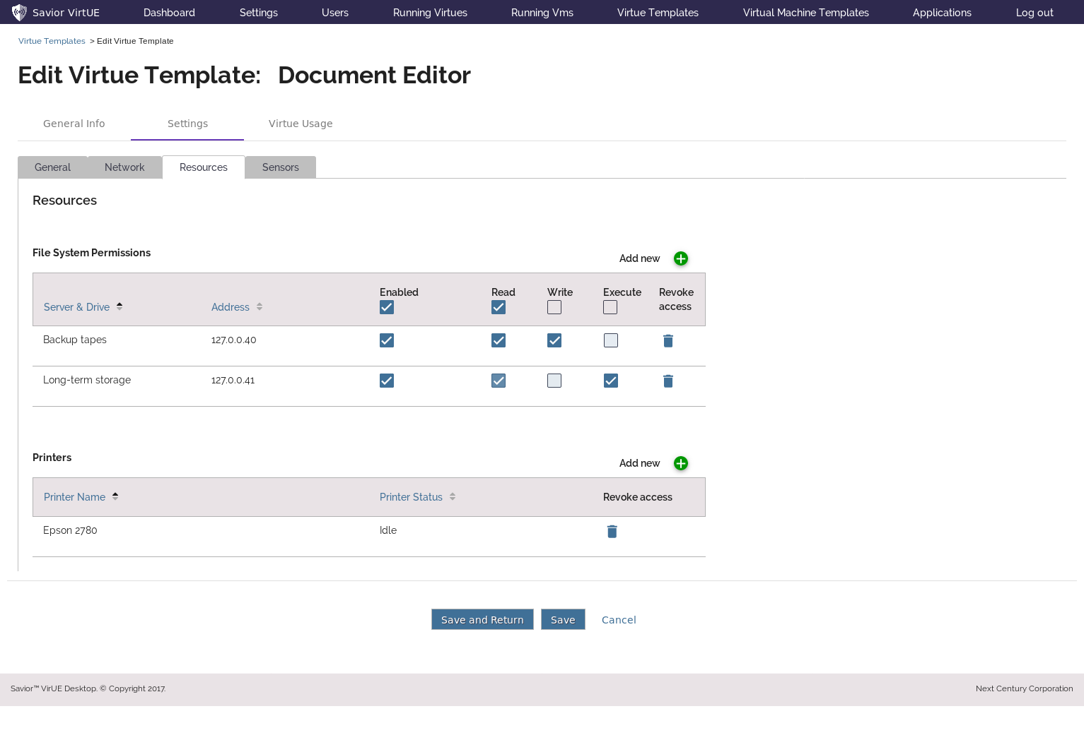

Figure 27 - Edit Virtue Template - Resource Changes Applied

# Virtue details – Manage Virtue Sensors

This tab would allow the administrator to set the vigilance levels for the sensors on this virtue. Sensors would come in with a default, globally-defined, value. This functionality may be implemented in a later version.

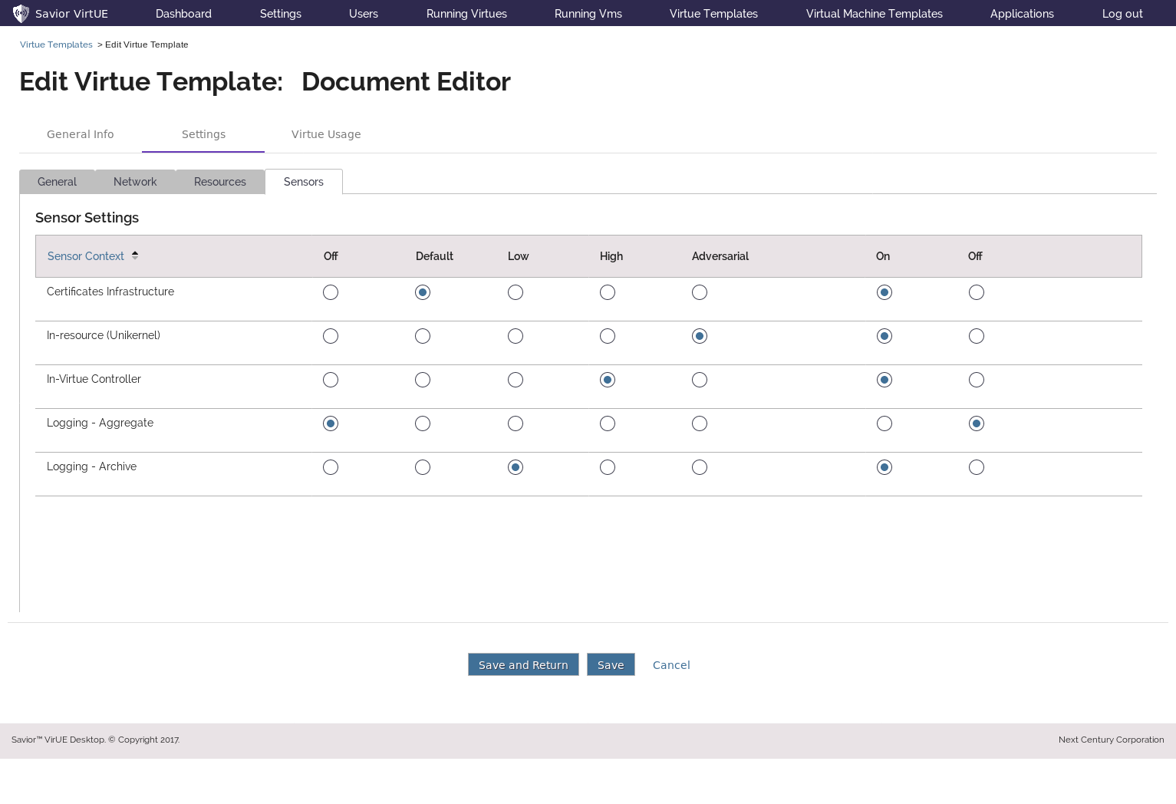

Figure 28 - Edit Virtue Template – Sensor Settings

# Virtue details – Virtue Usage

This allows the user to view the places where this virtue template is being used or referenced.

Included is a list of the users that have access to this virtue, as well as the Virtue instances which have been created from this template (if any).

In the future, the virtues which have been given clipboard permissions to this one will be included here as well.

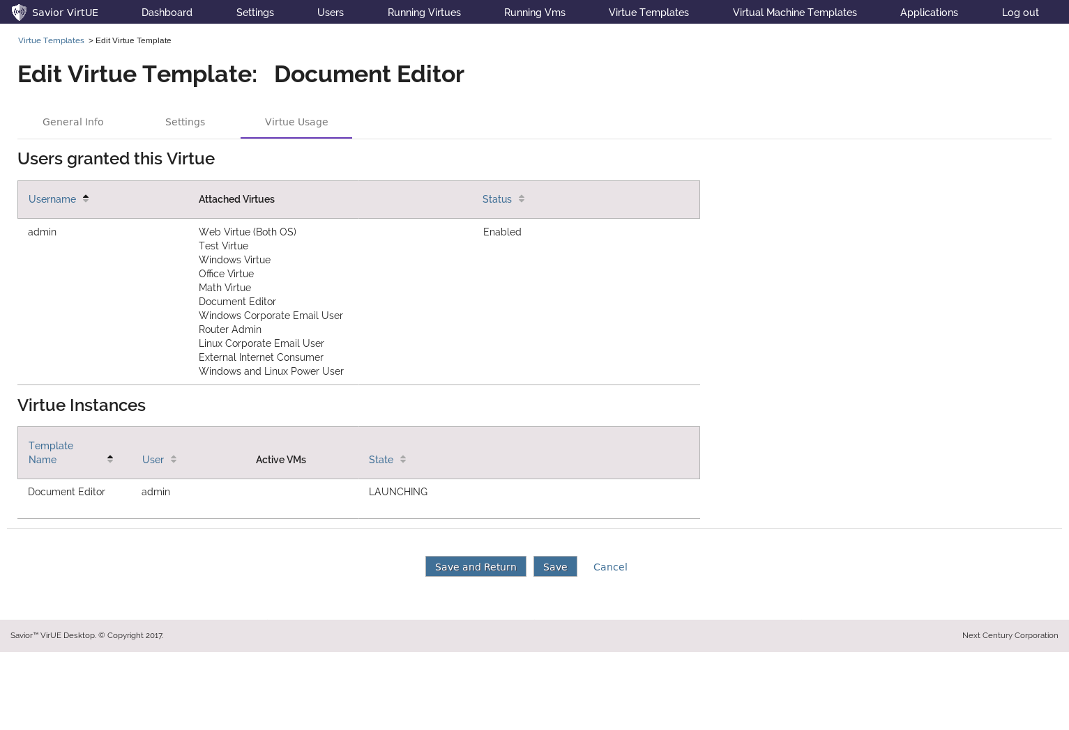

Figure 29 - Edit/View Virtue Template - Virtue Usage

# Virtual Machine details – View Page

From the Virtual Machine Template View page, the administrator can view details about the VM template, as well as enable/disable it.

As in the other pages, editing can be enabled on this template via the ‘Edit’ button at the bottom of the screen.

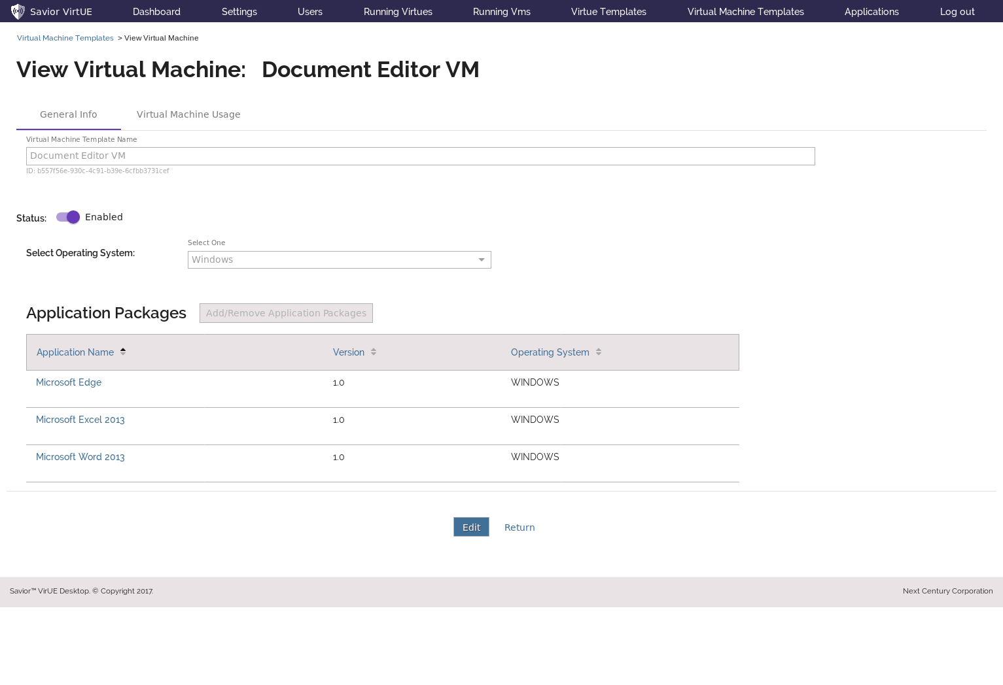

Figure 30 - View Virtual Machine Template

# Virtual Machine details – Edit Page

On the Virtual Machine Template Edit screen, the administrator can manage the VM’s attributes.

Use the dropdown to select the operating system for the VM to use – currently either Linux or Windows.

Use the ‘Add/Remove Application Packages’ button’ to select the applications which this VM should have.

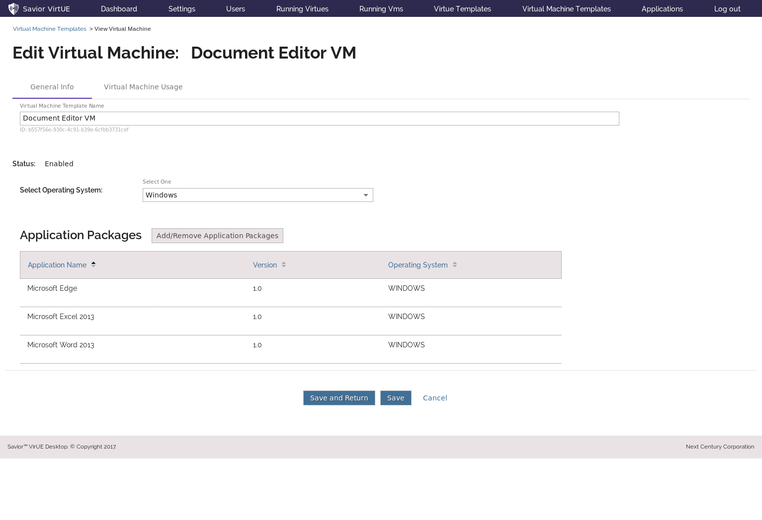

Figure 31 - Edit Virtual Machine Template

# Virtual Machine details – Add Applications

This pop-up shows the selection of applications which can be given to this machine.

In the future, a filter will be added so that only applications for an operating system matching that of the VM will show up.

Applications can be selected individually using the checkboxes on the left, or they can all be selected/deselected using the master checkbox in the header.

Select ‘Submit’ to add the selected templates to this virtue, or ‘Cancel’ to discard your changes.

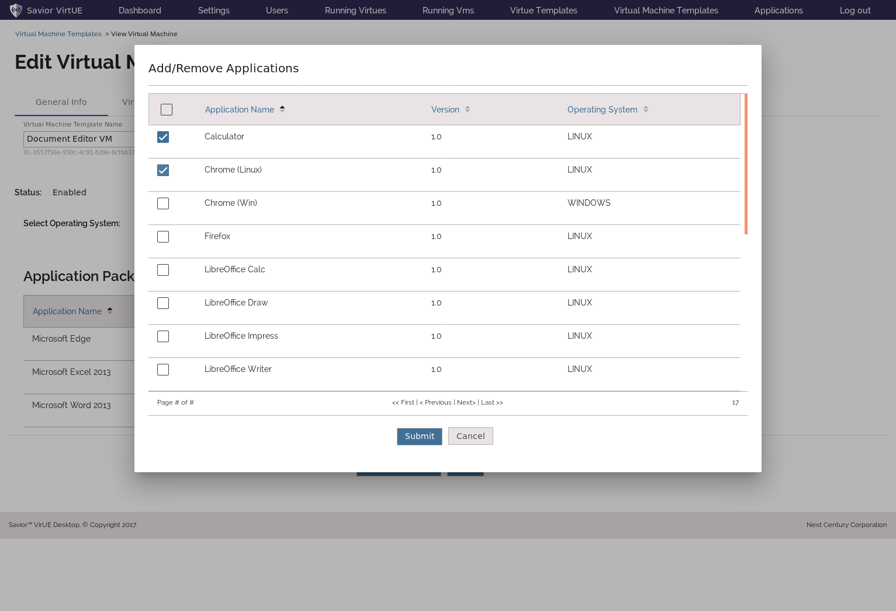

Figure 32 - Edit Virtual Machine Template - Add Apps

# Virtual Machine details – Usage Page

The Virtual Machine Template Usage screen lists the Virtue Templates which have been given access to this VM, and in the future will also list the VM instances which have been created from this template.

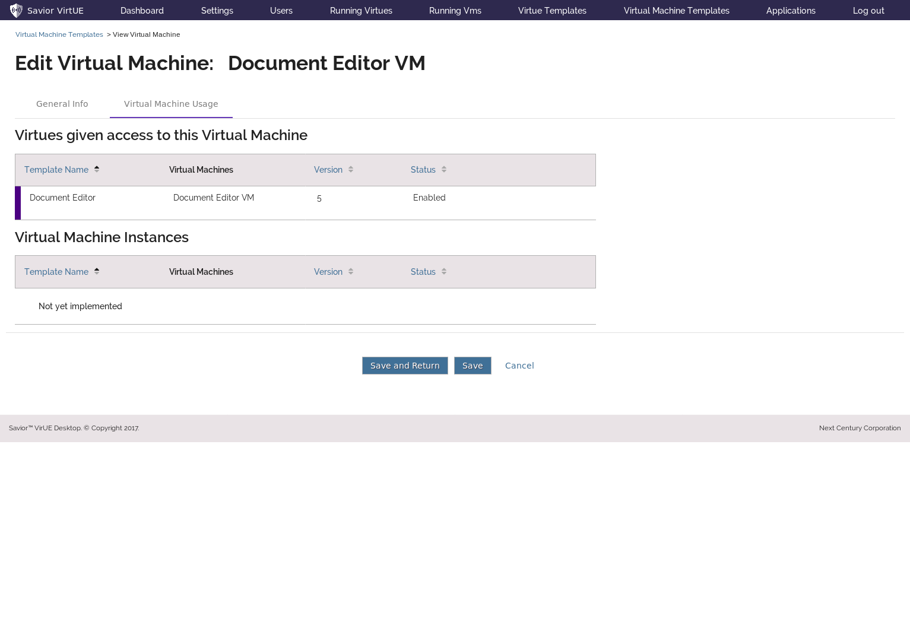

Figure 33 - Edit/View Virtual Machine Template Usage